

**Online Shoe Sales Website Project "KIA SHOP"**

**Final Release Document**

– Can Tho in March ,2024 –

Catalog

I. Deliverable Package 4

II. Installation Guides 4

1. Java Development Kit (JDK) 4

Before downloading NetBeans IDE, we need to download the Java Development Kit (JDK). 4

2. NetBean IDE 7

III. User Manual 12

1. Filter Products By Category 12

2. Sort Product Workflow 13

3. Search For Product 15

4.Filter Product By Price 17

5. View BestSeller Product 18

6. See the Web's latest products 19

7. Account Register 20

8. Forgot Password 23

9. Login 26

10. Update Quantity Cart 27

11. Order Product 28

12. Profile Management 31

13. View Order history 34

14. Cancel Order 34

15. view order details 36

16. Add New Product Workflow 38

17. Update Product 42

18. Customer Management Workflow 44

19. Order Management 47

# I. Deliverable Package

| **No.** | **File** | **Notes** |
| --- | --- | --- |
| 1 | KIA-SHOP5.sql | Database, including both table structures and table data |
| 2 | Template3_SRS_final.docx | Final SRS (Requirement) Document |
| 3 | Template2 _SDS_final.docx | Final SDS (Design) Document |
| 4 | Backlog_Group_1_Kia_Shop.xlsx | Final status for the application functions, which include:  - Function name, feature, roles, function description (changes compared to the original requirements are highlighted)  - In Charge, Planned iteration & Actual iteration  - Final status & note on the update you made  - The links to the SRS & SDS are tracked |

*XYZ include the student’s group code & project code (i.e: G1-HRM, for the group G1 who develop the Human Resource Management system).*

Other related deliverables:

* Tagged source codes: <<git lab tag link>>
* Demonstration video: <<YouTube link>>

# II. Installation Guides

## **1. Java Development Kit (JDK)**

## Before downloading NetBeans IDE, we need to download the Java Development Kit (JDK).

**Step 1:** Visit the [Java Downloads | Oracle](https://www.oracle.com/java/technologies/downloads/) website and select JDK download.

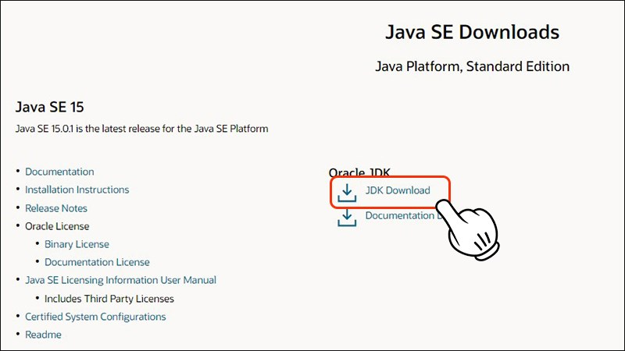

**Step 2:** Select the JDK version suitable for the operating system used (Windows).

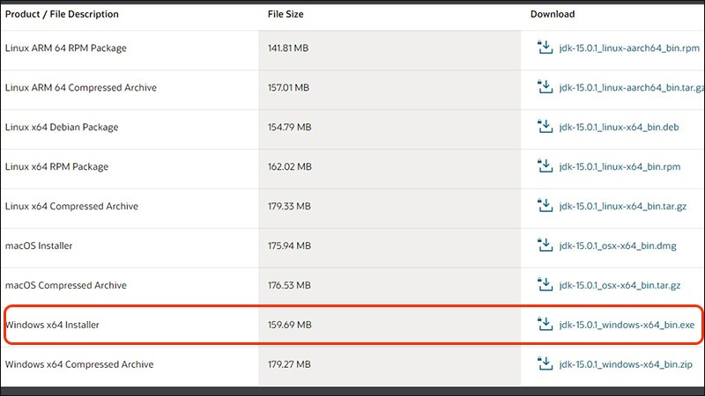

**Step 3:** Click to check **I reviewed and accept the Oracle Technology Network License Agreement for Oracle Java SE** and then click **Download**.

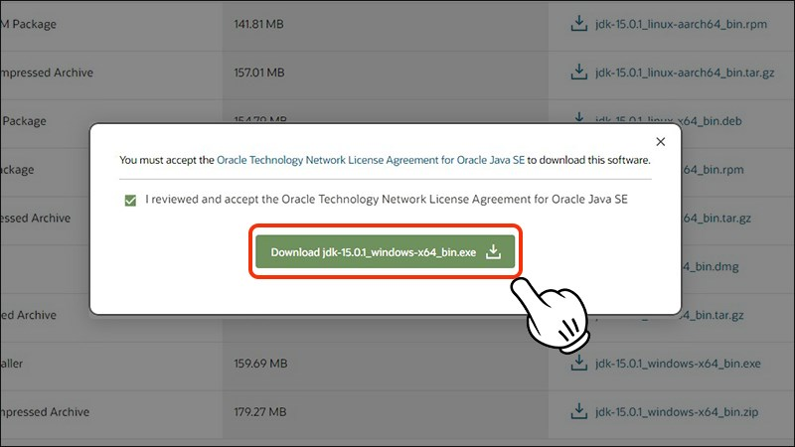

**Step 4:** Once the download is complete. Open the file you just downloaded and then click **Run**.

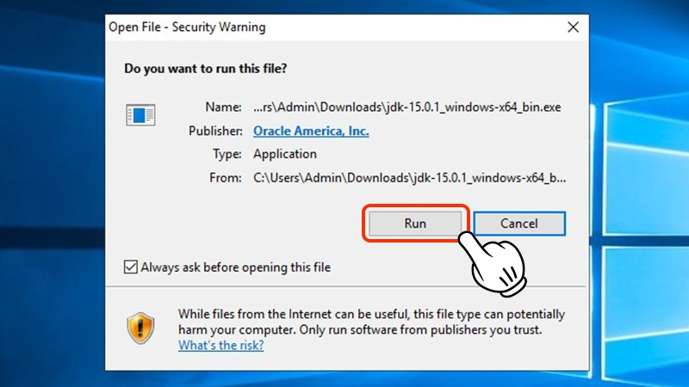

**Step 5:** Click Next to start the installation.

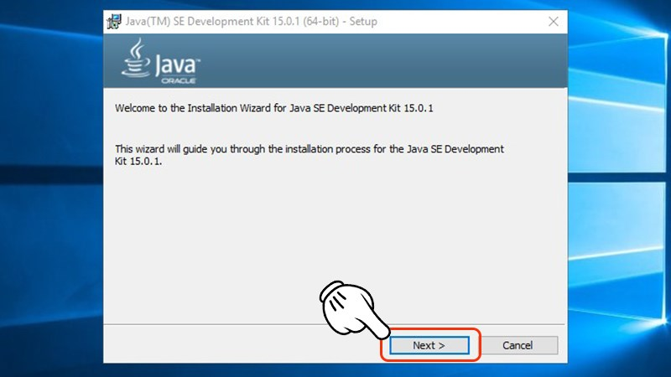

**Step 6:** Next you can choose where to save the folder, otherwise it will default to drive C. Then click **Next** to continue.

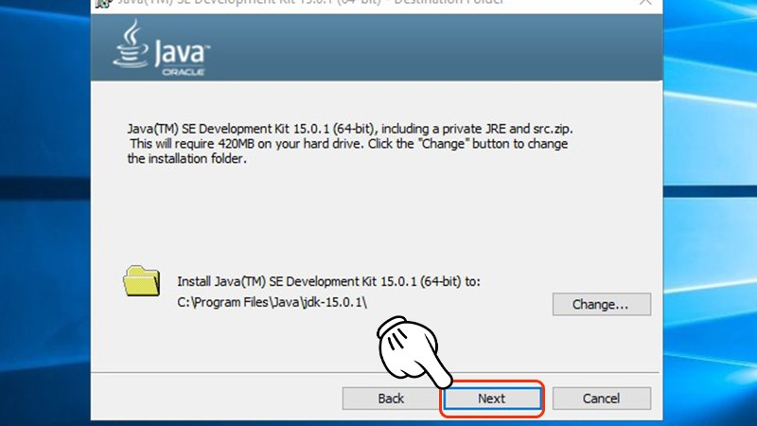

**Step 7:** Now you just need to click **Close** to complete the JDK installation.

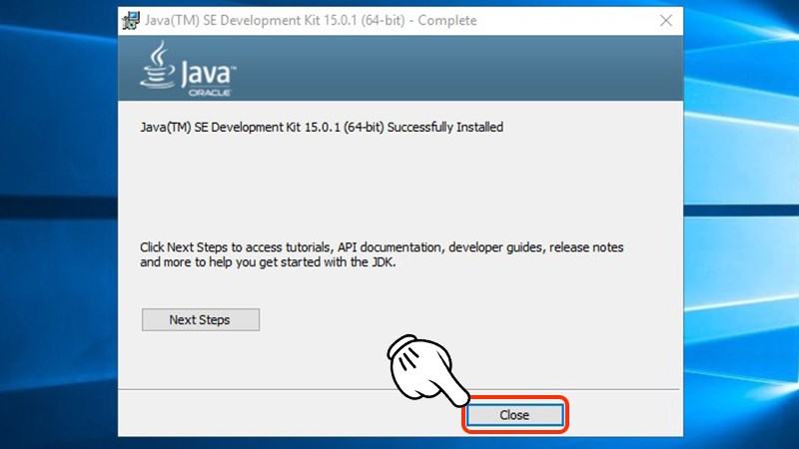

## **2. NetBean IDE**

**Step 1:** Go to [Apache NetBeans Releases](https://netbeans.apache.org/front/main/download/index.html) website, select Download the latest version.

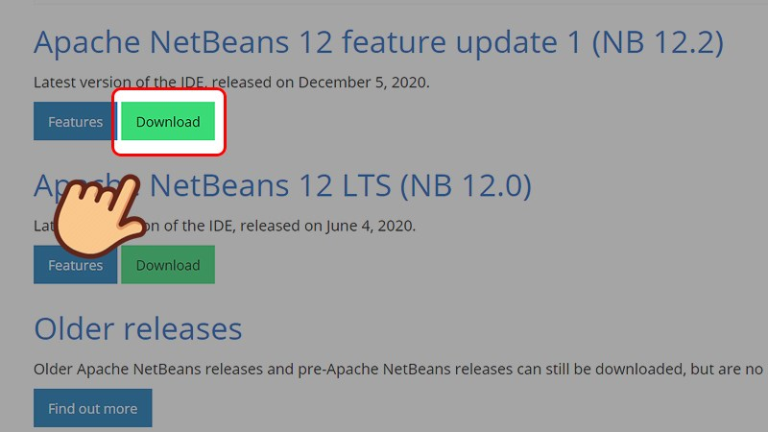

**Step 2:** In the **Installers** section, choose to download according to your platform. Here I use Windows so I will choose the Windows platform.

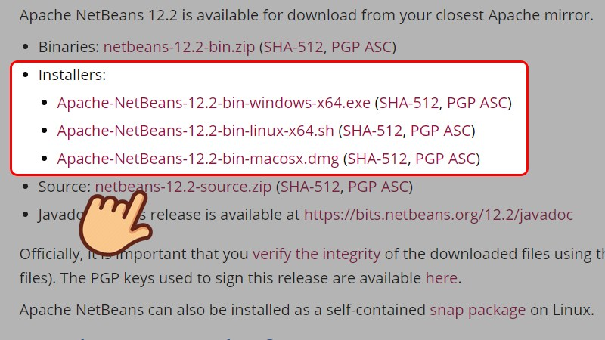

**Step 3:** Select the link after the **We suggest the following mirror site for your download line**.

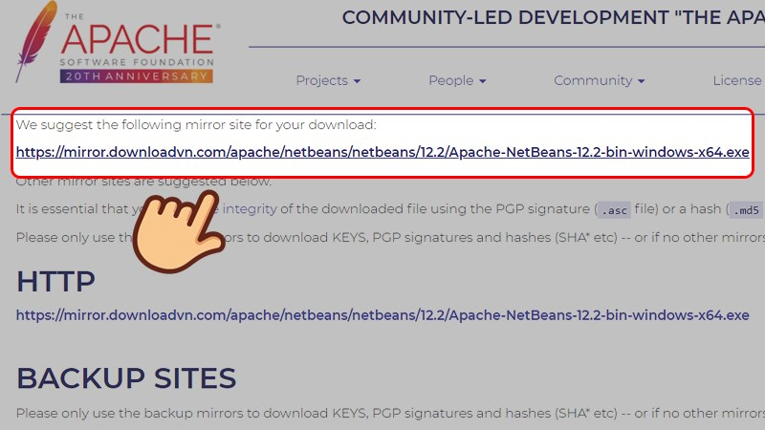

**Step 4:** Choose where to save the file and select **Save**.

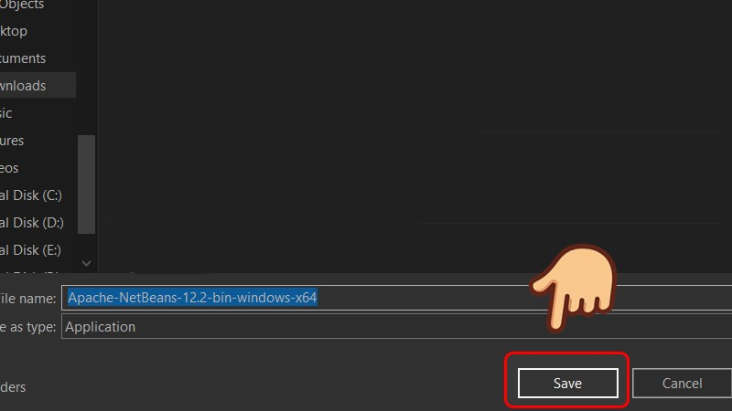

**Step 5:** Once downloaded, right-click on the NetBeans IDE icon and select **Run as administrator**.

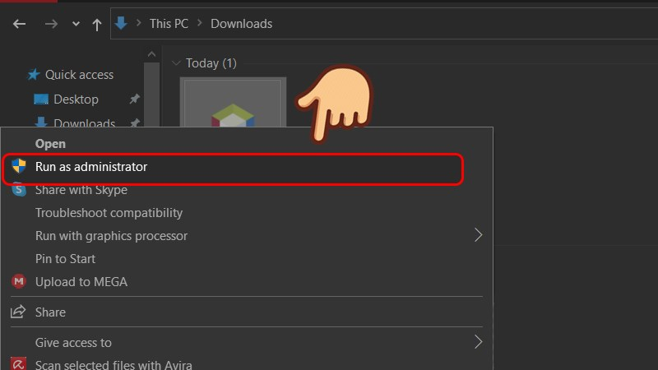

**Step 6:** The installation interface appears showing supported programming languages. You can go to **Customize…** to choose more or less languages. Select **Next** to continue the installation process.

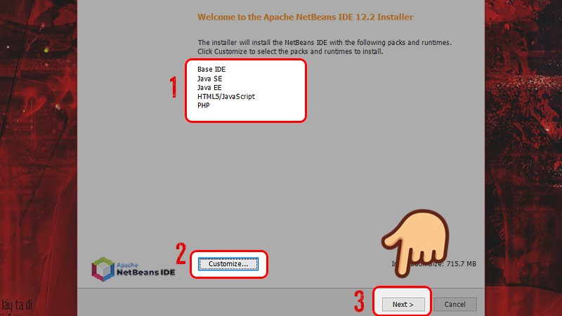

**Step 7:** Check the box **I accept the terms in the license agreement** and select **Next**.

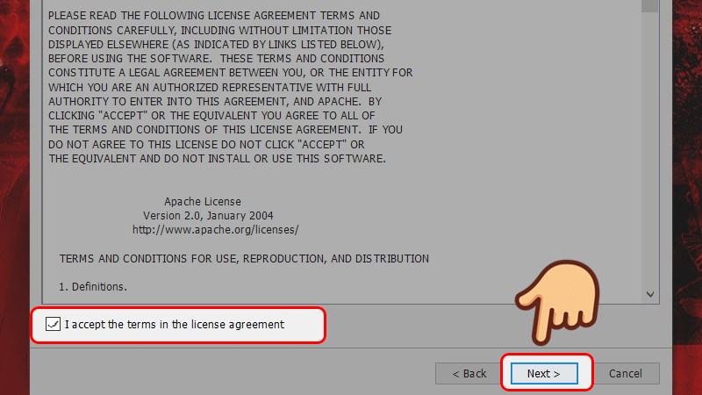

**Step 8:** The installer will automatically find where NetBeans IDE is installed and find the location where the newly installed JDK is stored. If you want to change the installation drive, you can change it back by selecting **Browse** and choosing where you want to install. Then select **Next** to continue the installation process.

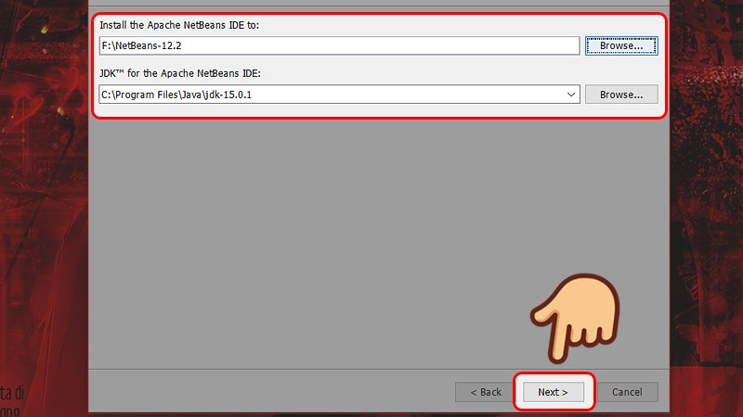

**Step 9:** Check the **Check for Update** check box to check that NetBeans has an immediately updated version. Select **Install** to proceed with the installation process.

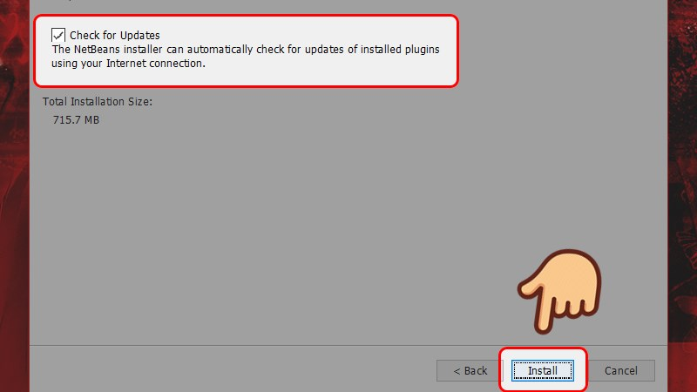

**Step 10:** Select **Finish** to finish the NetBeans IDE installation process.

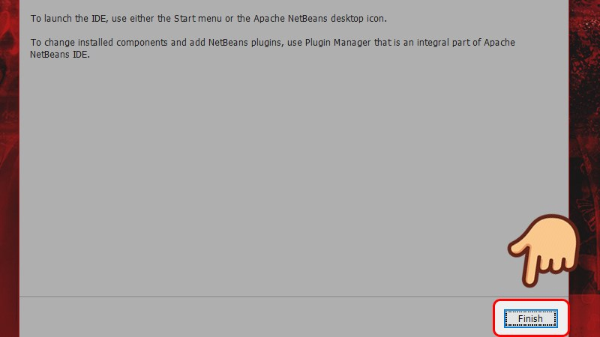

# III. User Manual

## 1. Filter Products By Category

Purpose: the process of filtering products by category helps customers see products belonging to desired brands, making it more convenient to purchase.

Detail:

Step 1: When accessing the website, you can log in or not log in to use product filtering

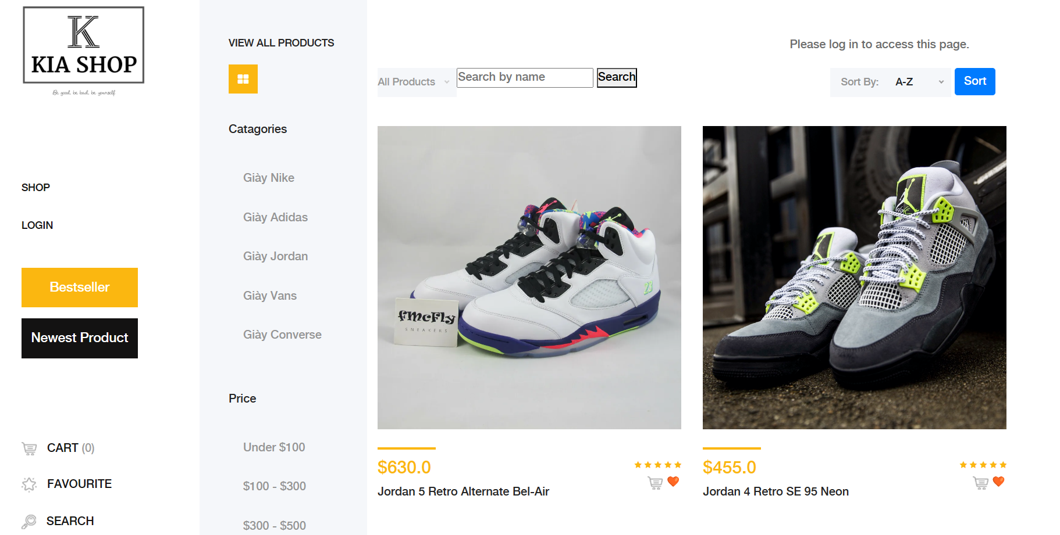Step 2: select the category in which you want to see products belonging to that category

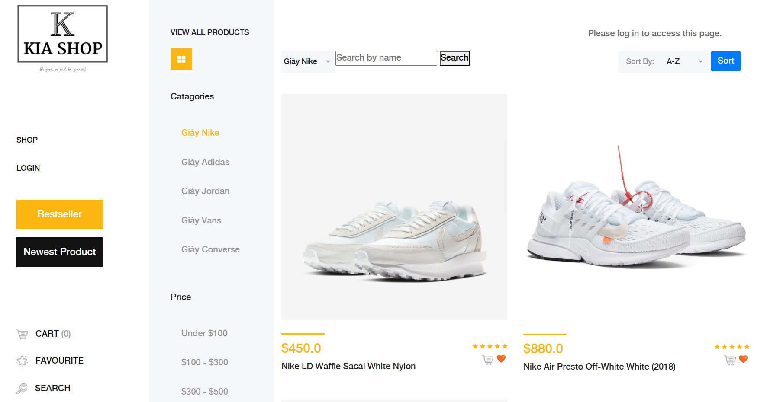Step 3: the system displays products arranged by category

## 2. Sort Product Workflow

Purpose:The Sort Product workflow allows users to organize and arrange product listings based on their preferences, enabling a more tailored and efficient shopping experience within the KiaShop application.

Details:

Step 1: Accessing Sorting Options

- Upon navigating to a product category or search results page, users will find a sorting option near the top or bottom of the list of products.

- Look for a dropdown menu or sorting icon/button that indicates the availability of sorting options.

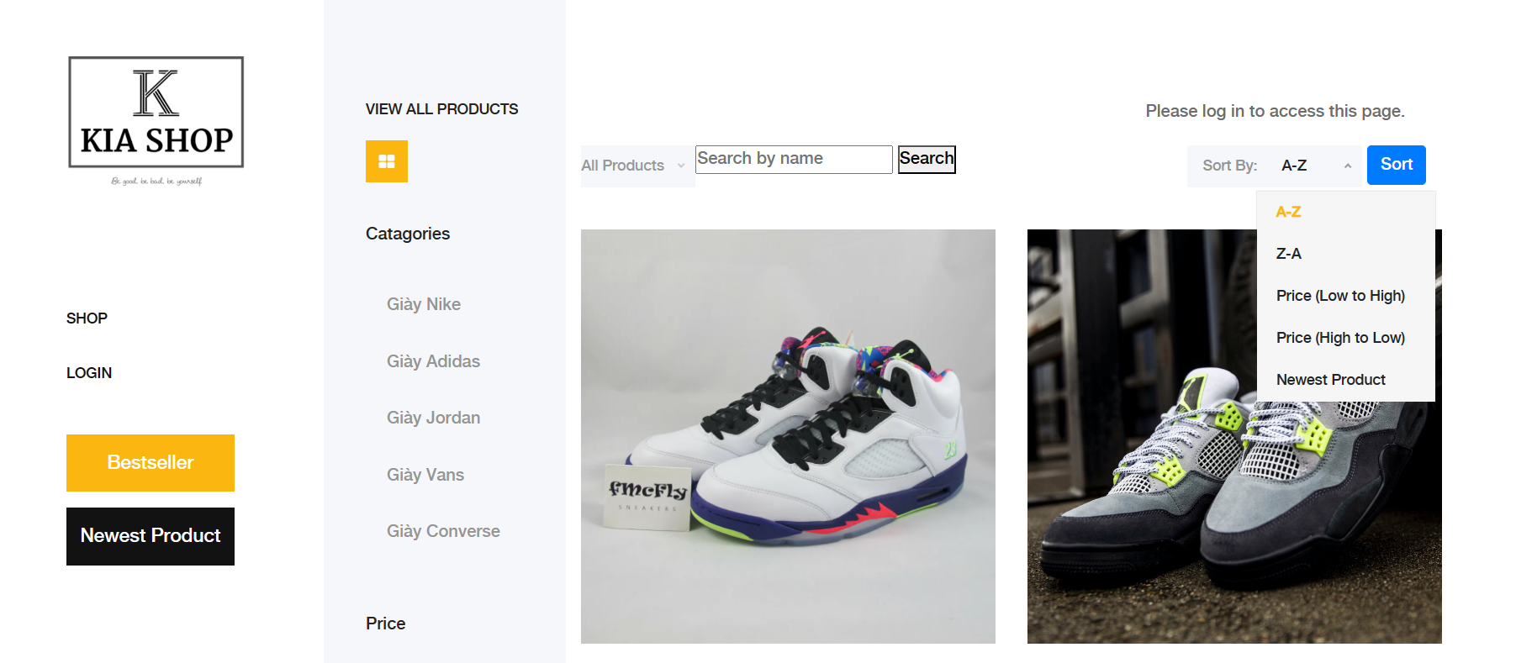Step 2: Selecting Sorting Criteria

- Click on the dropdown menu or sorting icon/button to reveal the available sorting criteria.- Common sorting options may include "Price: Low to High", "Price: High to Low", "Newest Arrivals", "Best Sellers", "Customer Ratings", etc.

- Choose the desired sorting criterion by clicking on it.

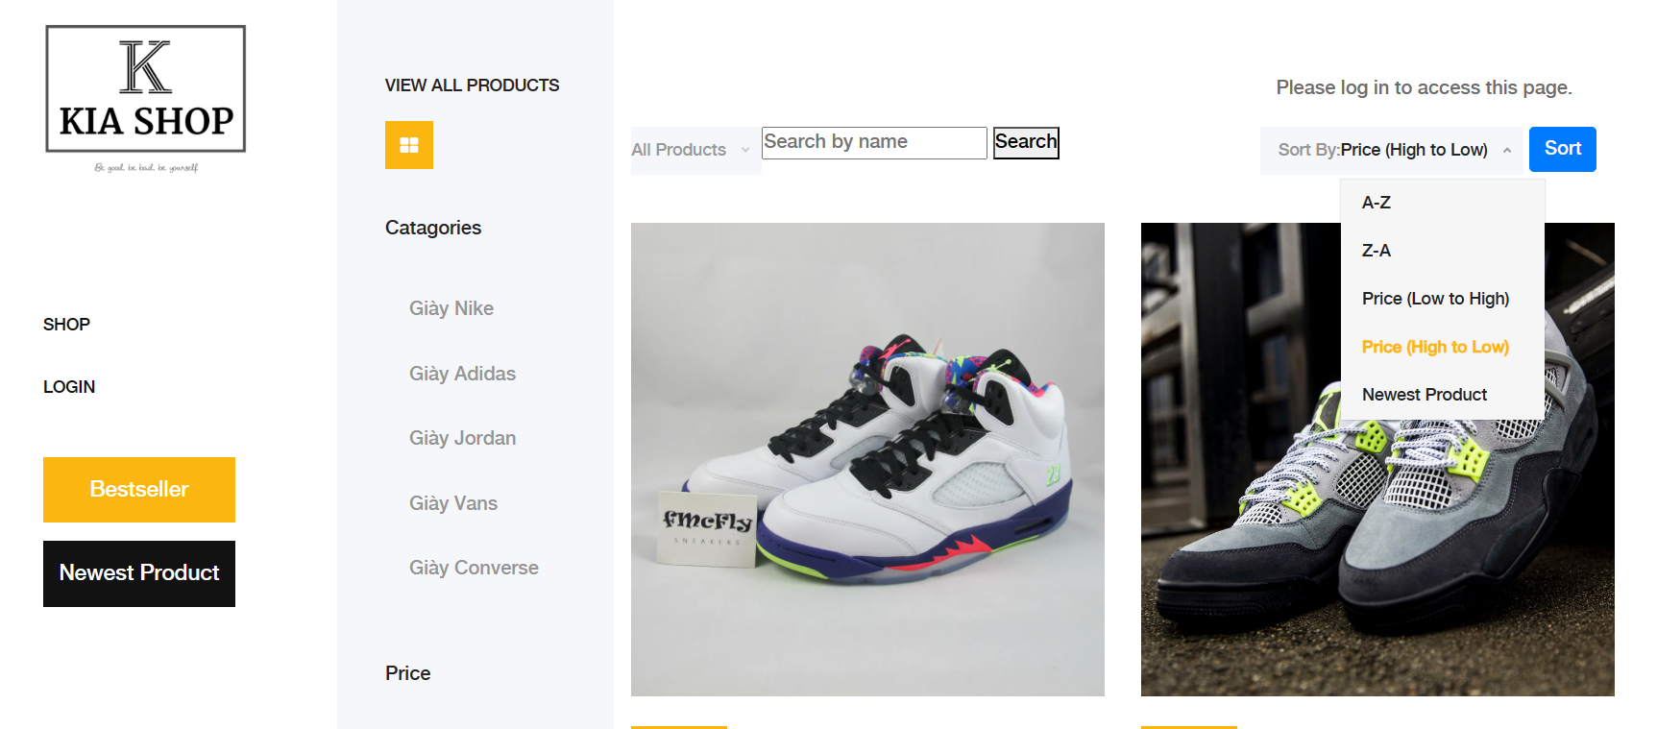Step 3: Applying the Sorting

- After selecting the sorting criterion, the product list will automatically reorganize based on the chosen criteria.

- Users can immediately see the updated order of products according to the selected sorting option.

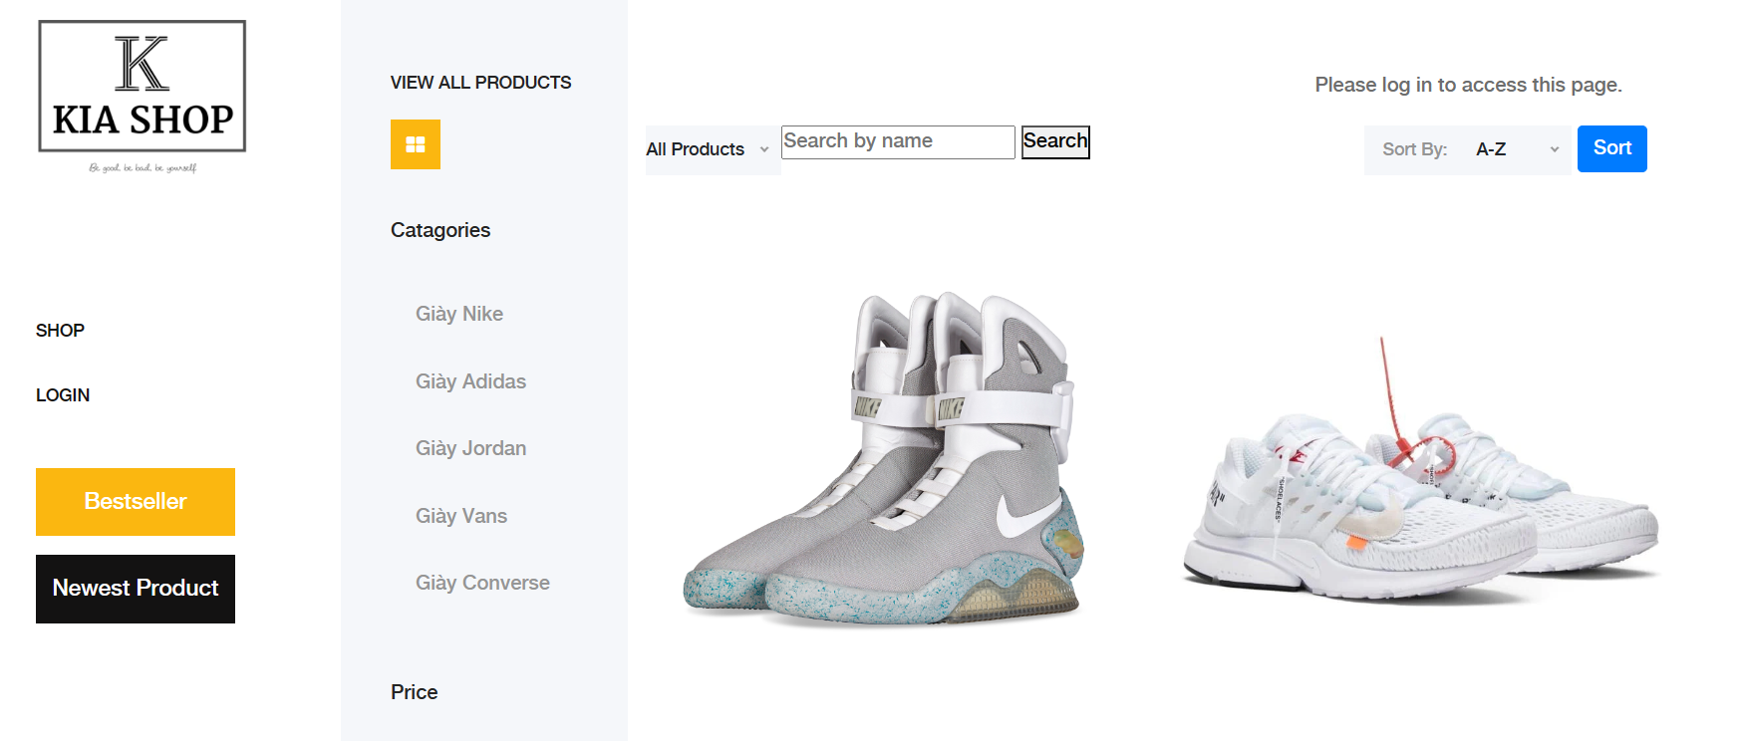Step 4: Exploring Sorted Products

- Browse through the newly sorted product list to find items that match the user's preferences.

- Users can now easily identify products that meet their specific criteria, such as price range, popularity, or product age.

Step 5: Revising Sorting Criteria

- If users wish to explore products based on different sorting criteria, they can repeat the process by accessing the sorting options again.

- Simply select a new sorting criterion from the dropdown menu or sorting icon/button to reorder the product list accordingly.

By following these steps, users can efficiently sort and organize product listings within the KiaShop application, enabling them to find products that best suit their preferences and needs.

## 3. Search For Product

Purpose: the product search process makes it more convenient for customers to search for products based on product names

Detail:

Step 1: Visit the website and you can log in or not log in to use the product search

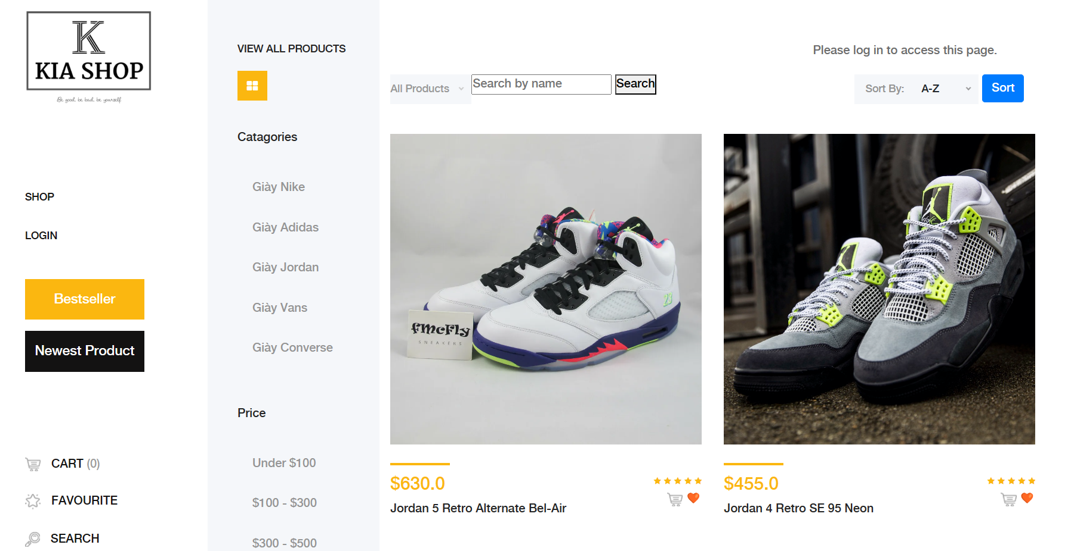Step 2:

- click on the Search By Name box

- Enter the product name you want to search for

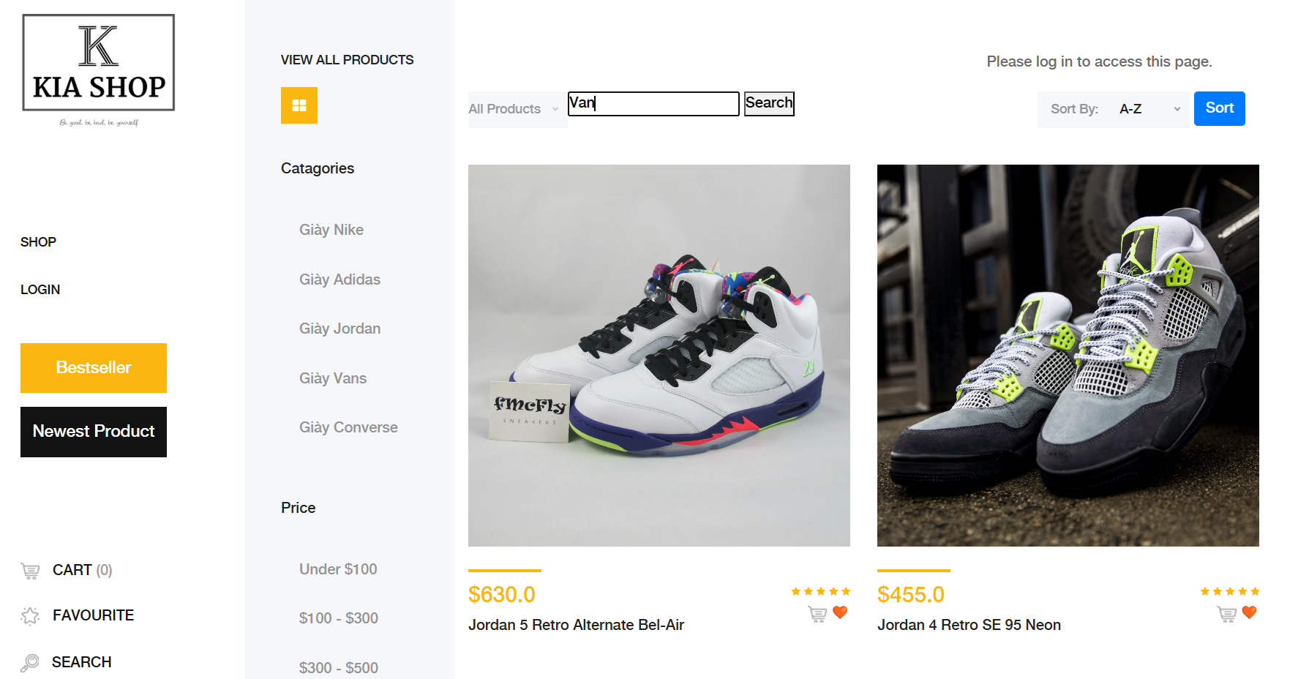Step 3: Click Search, the system will display the searched products

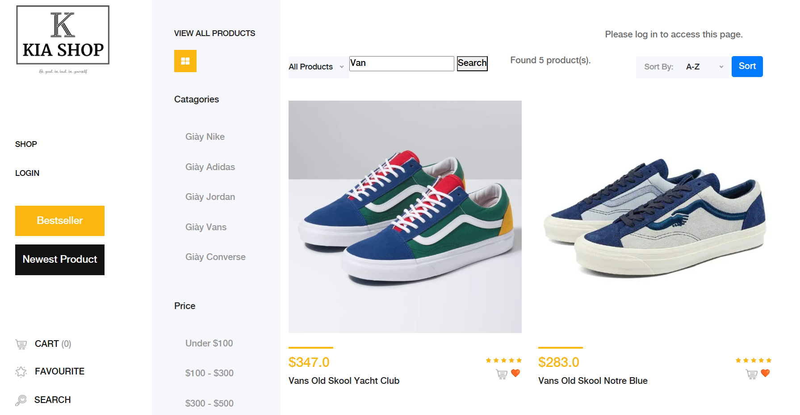

## 4.Filter Product By Price

Purpose: the process of filtering products by price helps customers filter products with the desired price

Detail:

Step 1: access the website, you can log in or not, all are filtered by price

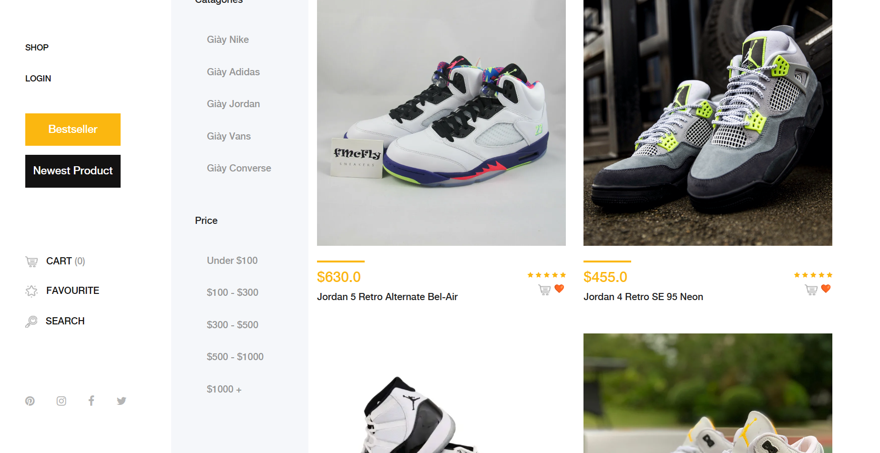Step 2:

- Select the desired price

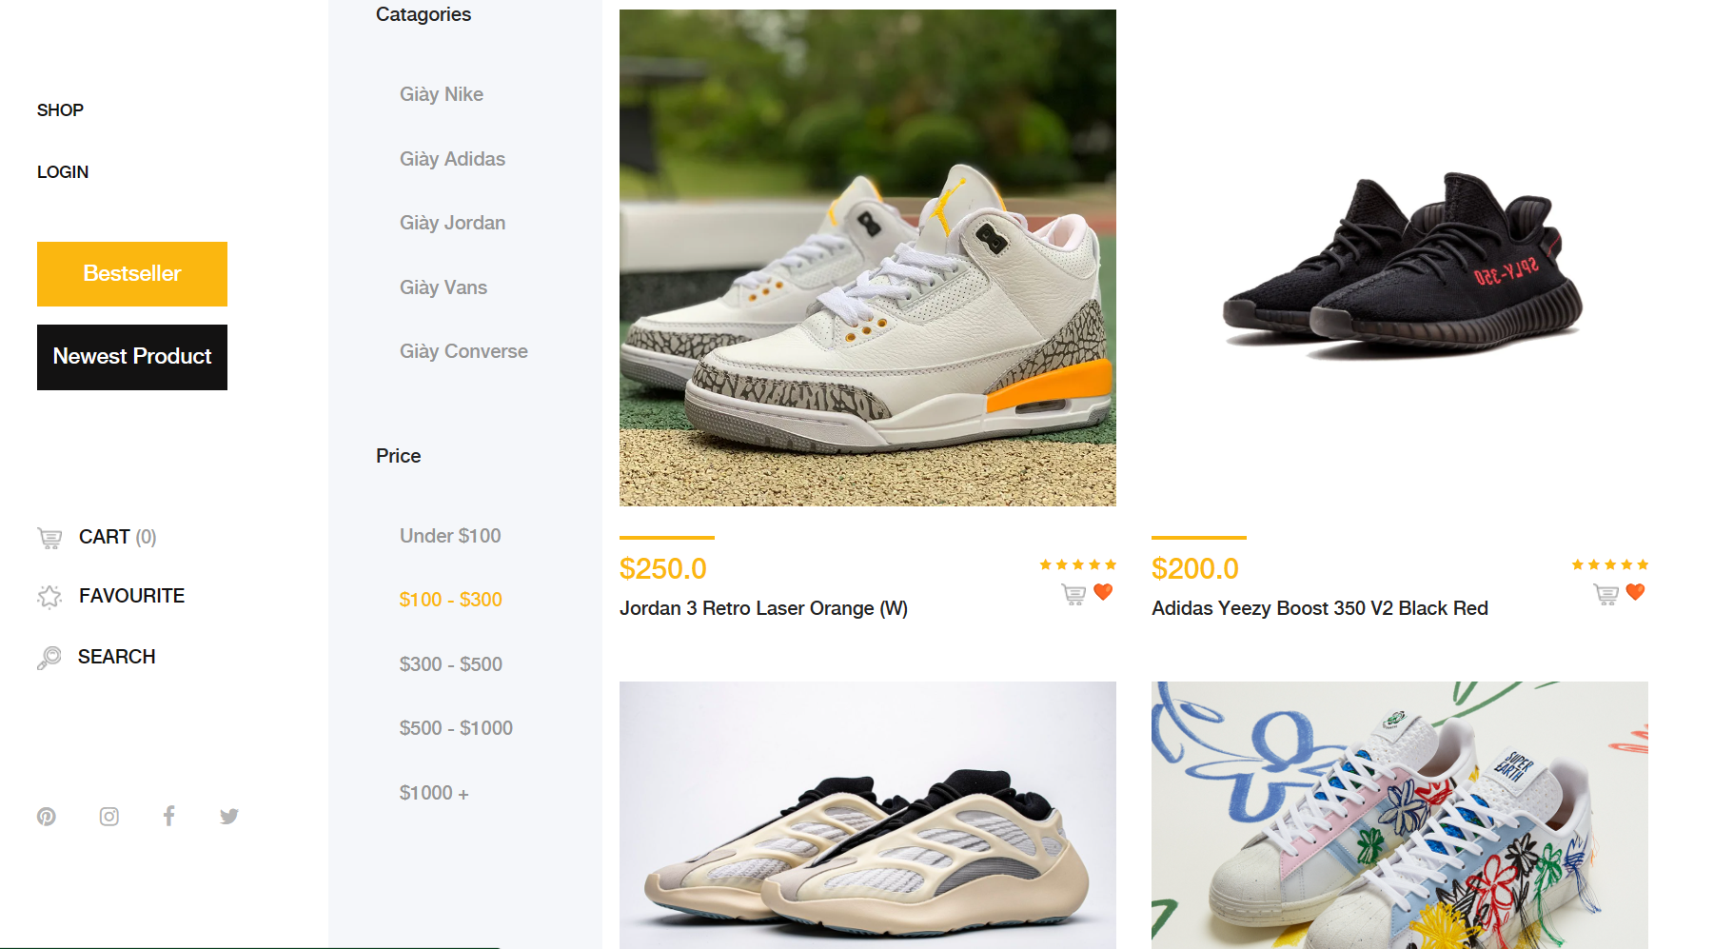Step 3: the system displays filtered products

## 5. View BestSeller Product

Purpose: see best-selling products in the web

Detail:

Step 1: Visit the website and you can log in or not to see the best selling products

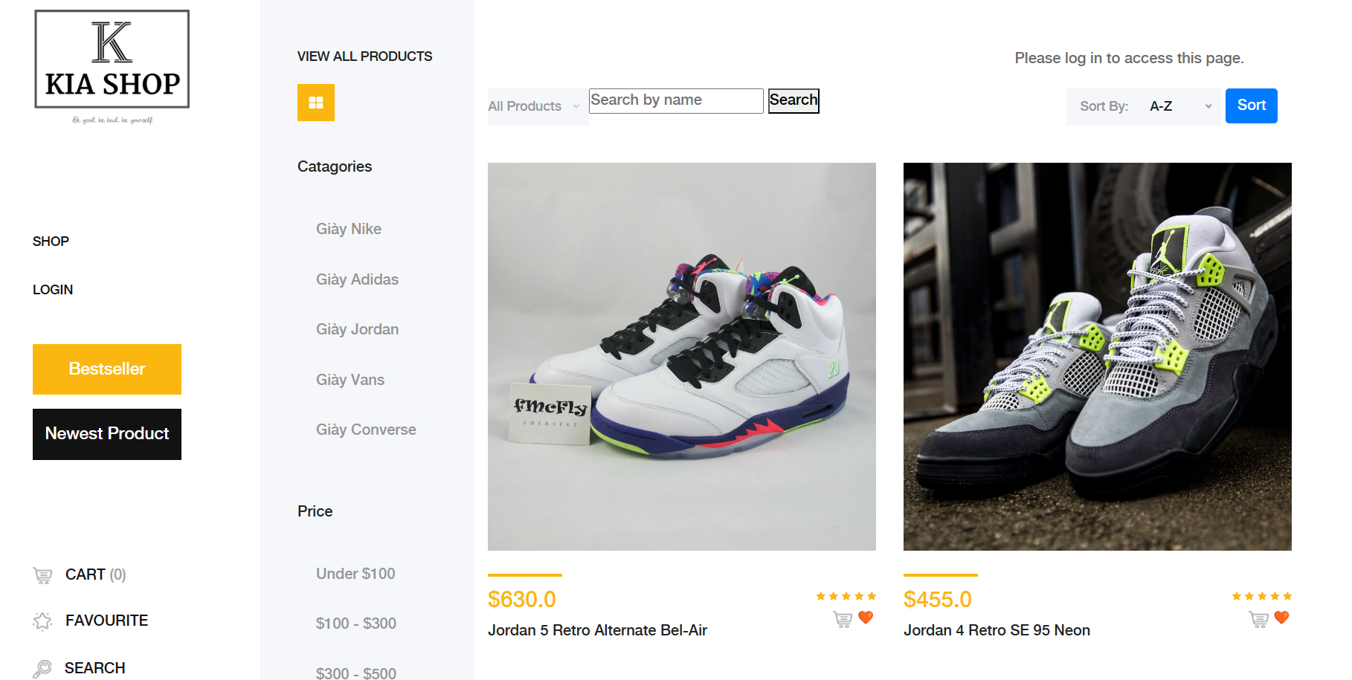Step 2:

- Select the Bestseller button

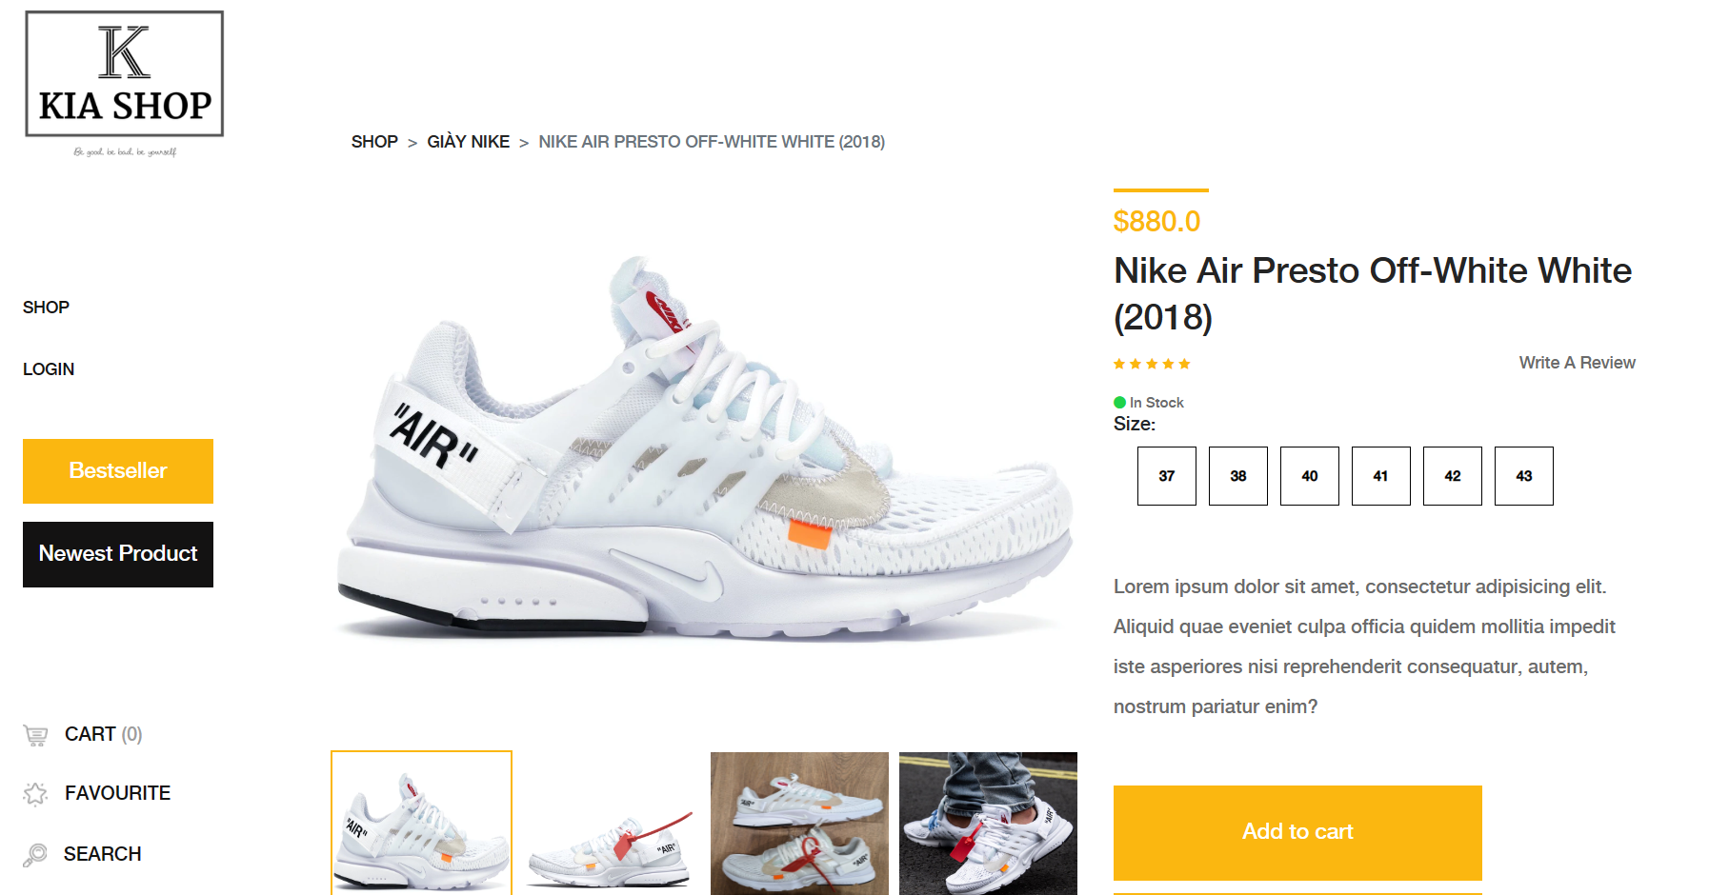Step 3: the system displays best-selling products

## 6. See the Web's latest products

Purpose: see the latest products in the web

Detail:

Step 1: Visit the website and you can log in or not to see the latest products

Step 2:

- select the Newest Product button

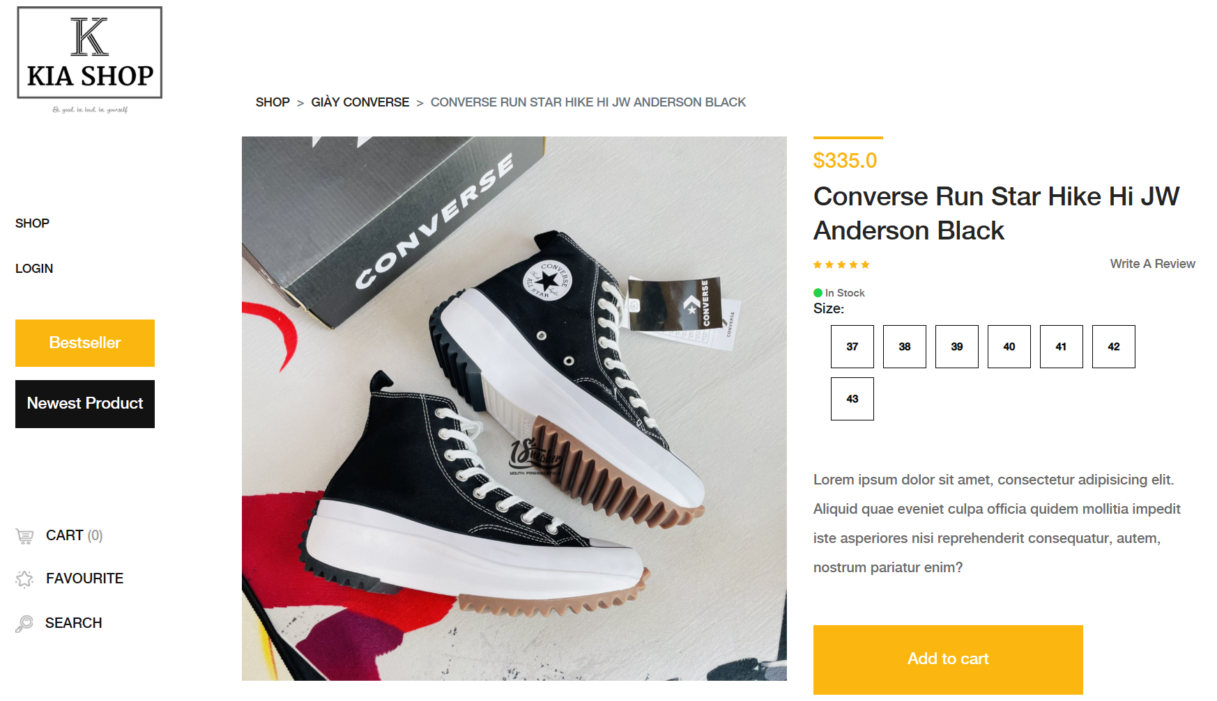Step 3: the system displays the latest products

## Account Register

Purpose: account creation process for new customers. Once the account is successfully created, you can perform activities such as adding to cart and making purchases.

Detail:

Step 1: Access the registration form

- When launching the KiaShop application, users will be greeted with the home page.

- The user selects the login button.

- In the login page, click the sign up button to create an account

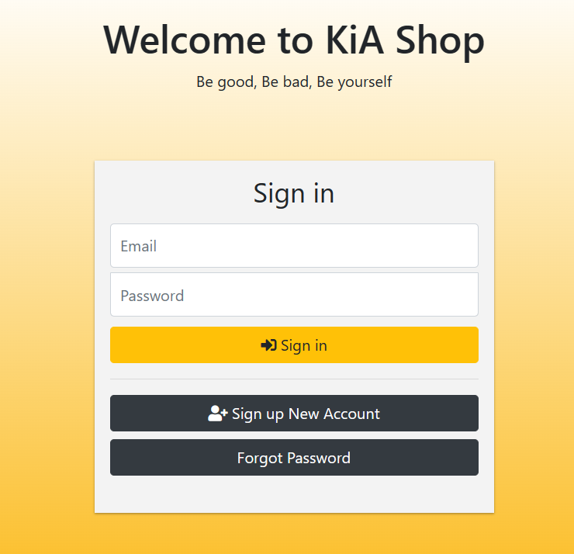

Step 2: Enter registration information

- Enter information such as fullname, email, password, repassword.

- Valid information such as full name must be at least 4 characters, email must be in the correct format like example@gmail.com, password must be at least 6 characters and repassword must match the password

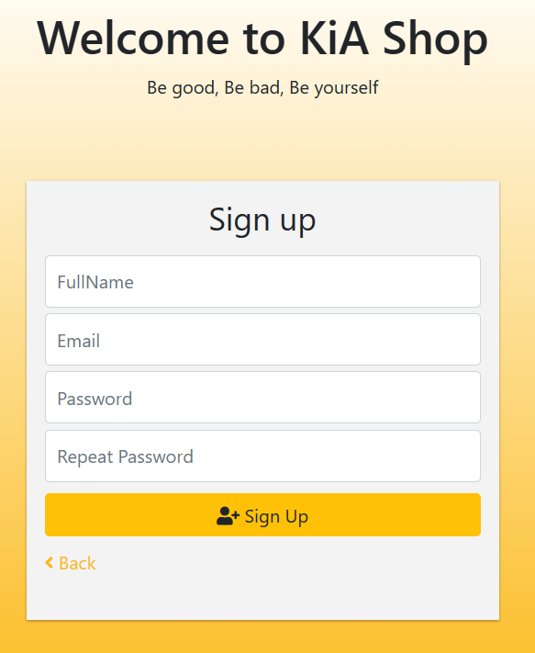

Step 3: verify account

- After clicking register, the system sends the pin code to the registered email

- authenticate the pin code to be able to return to the login page

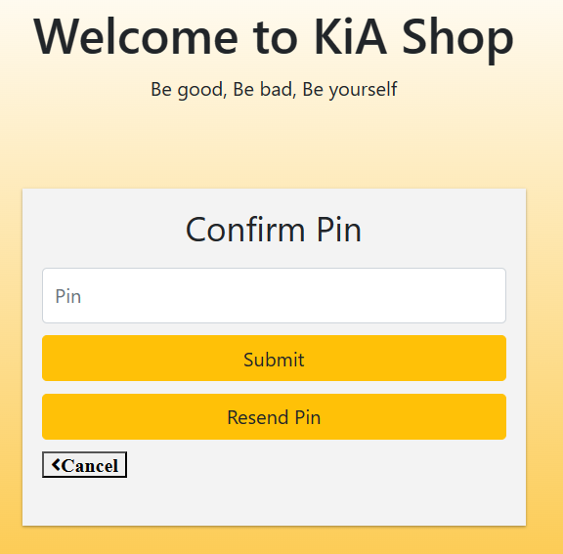

## 8. Forgot Password

Purpose: the forgotten password process helps customers create a new password to log into the system

Detail:

Step 1: Access the registration form

- When launching the KiaShop application, users will be greeted with the home page.

- The user selects the Login button

- In the login page, click the Forgot Password button to create an account



Step 2: Enter registered email

- Enter your registered email and re-enter your new password

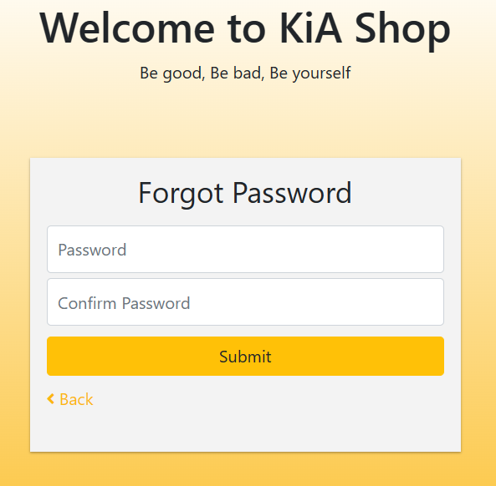

Step 3: verify account

- After clicking register, the system sends the pin code to the registered email

- authenticate the pin code to be able to return to the login page.

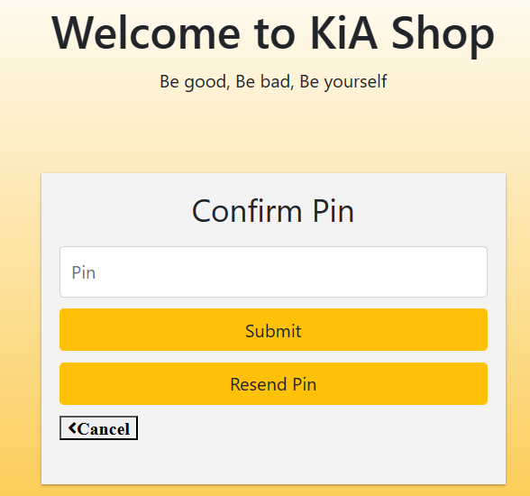

## 9. Login

Purpose: login process to registered account

Detail:

Step 1: Access the login form

- When launching the KiaShop application, users will be greeted with the home page.

- The user selects the Login button

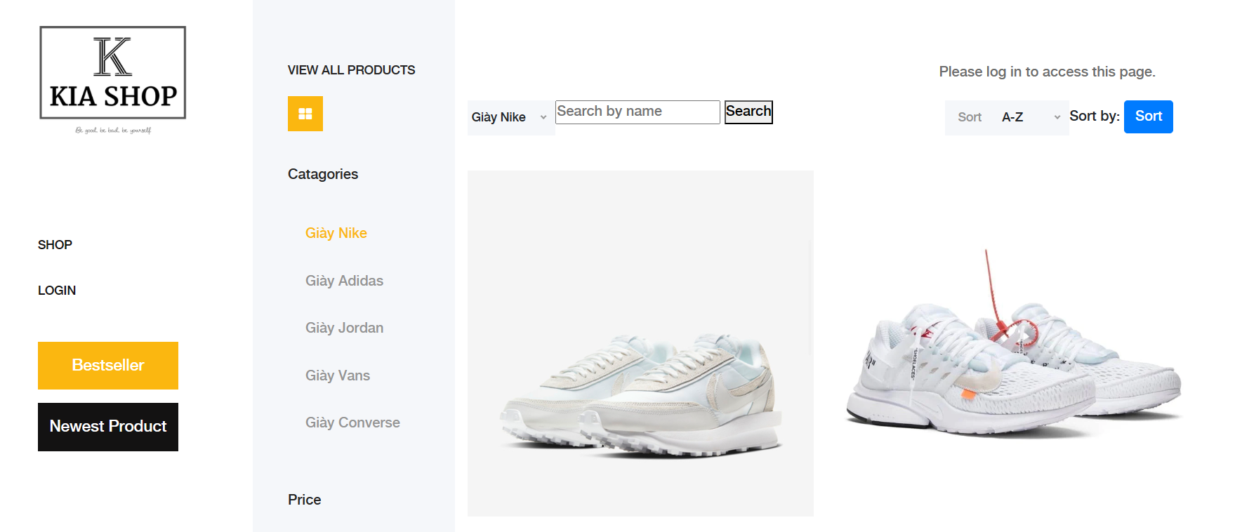

Step 2: Enter email and password

- enter email and password



## Update Quantity Cart

Purpose: process of adding products to cart and updating product quantity

Detail:

Step 1: log in to your account

- When launching the KiaShop application, users will be greeted with the home page.

- User selects Login to account button

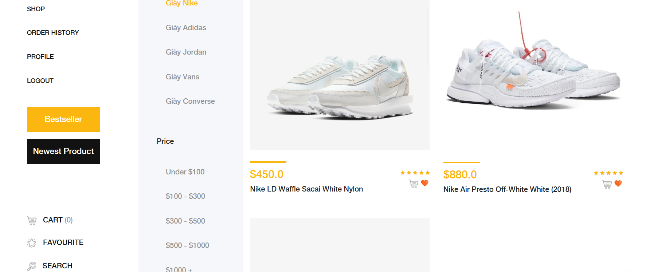

Step 2: go to cart

- Go to cart and update the product quantity

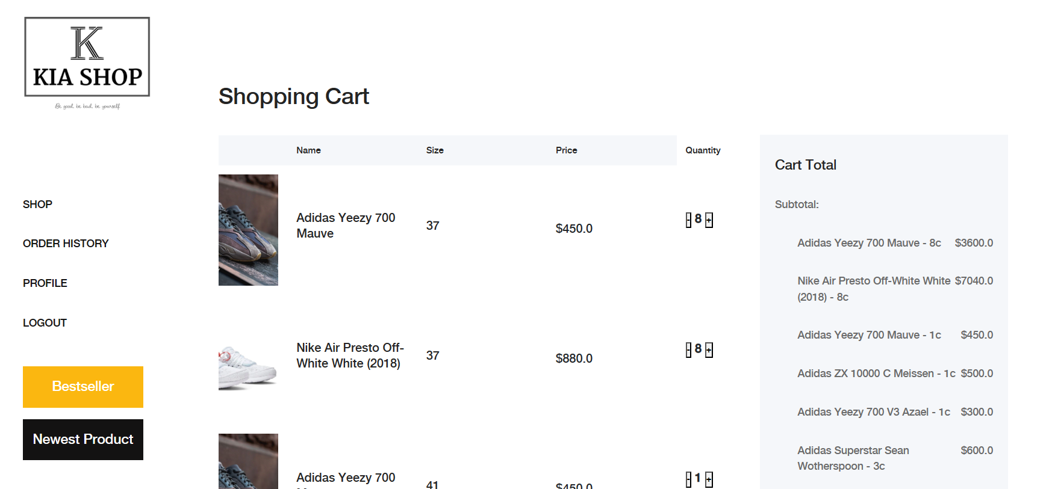

## 11. Order Product

Purpose: purchase products on the website

Detail:

Step 1: accessing the website requires you to log in to make a purchase

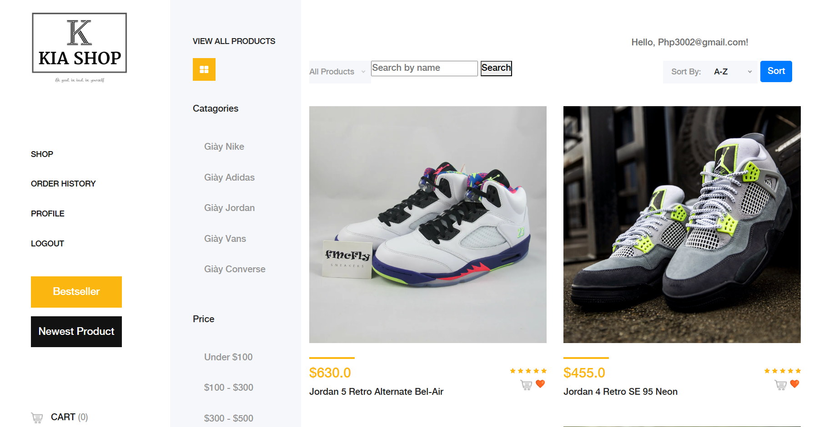Step 2:

- Select the product name to view product details

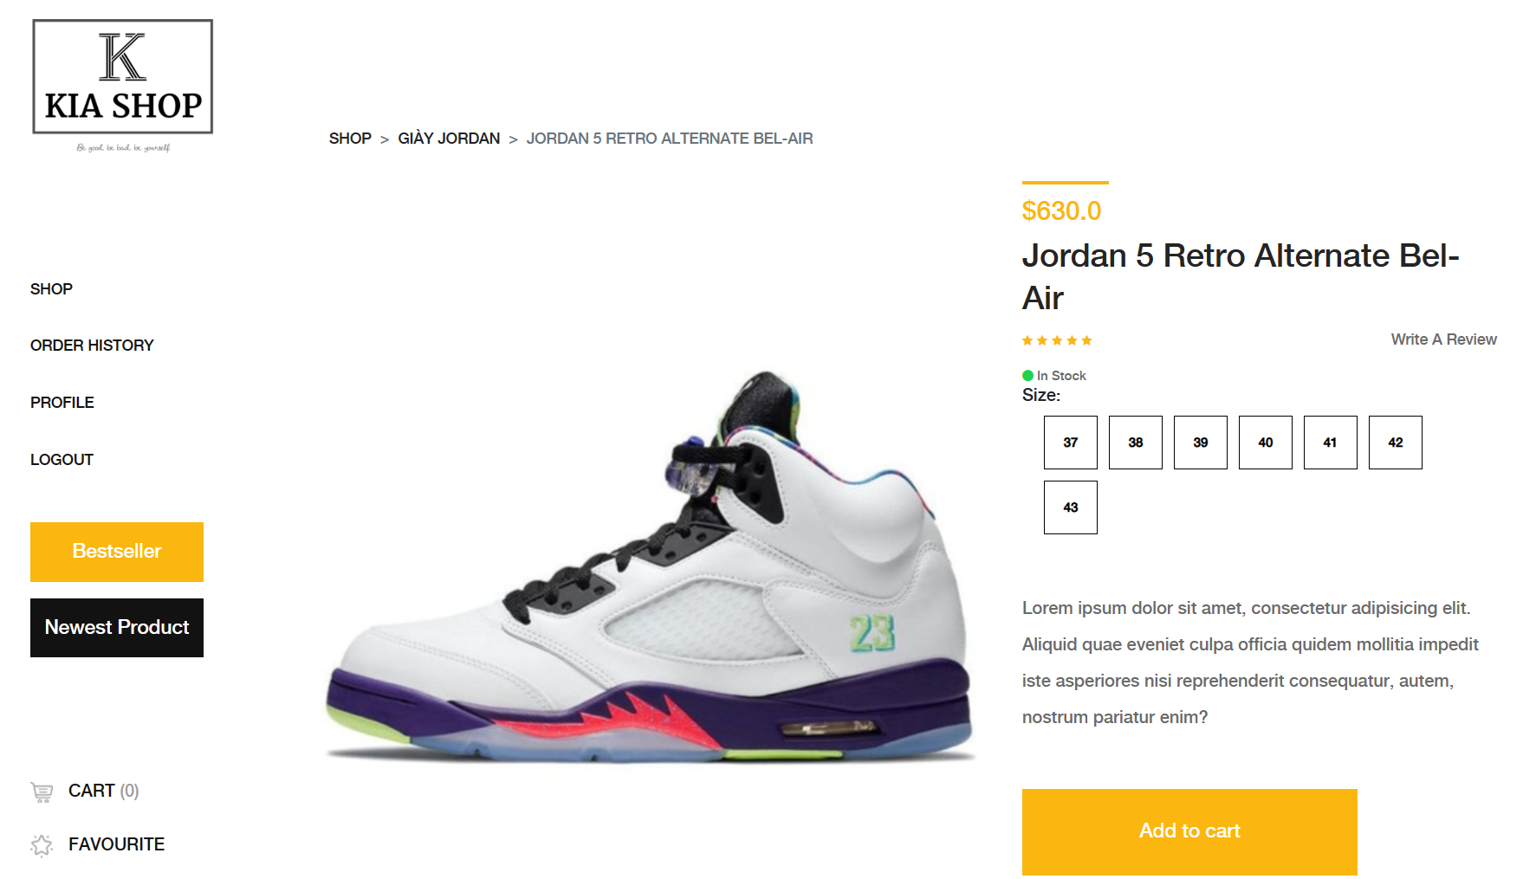Step 3: On the product detail page, select the desired size

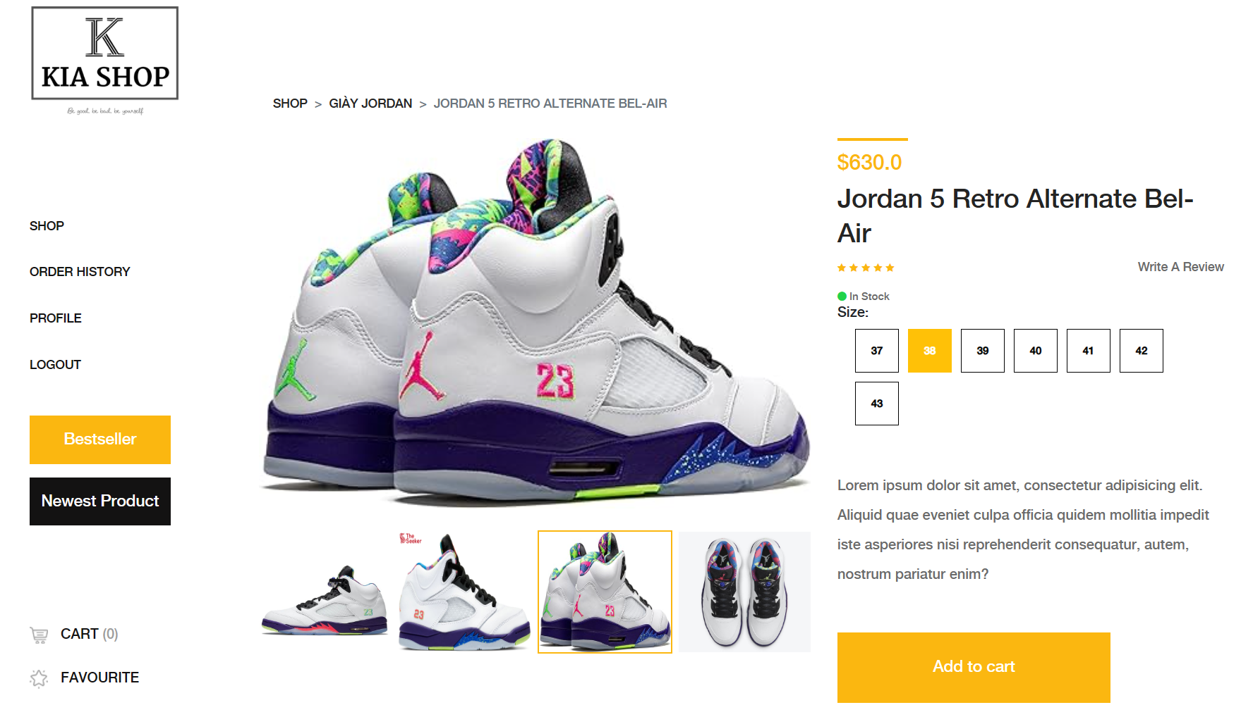

Step 4:

- After selecting the size is complete

- Select the Add To Cart button

- If you want to buy multiple products, go back to step 2

Step 5: When adding to cart you will see product information

- change the desired quantity

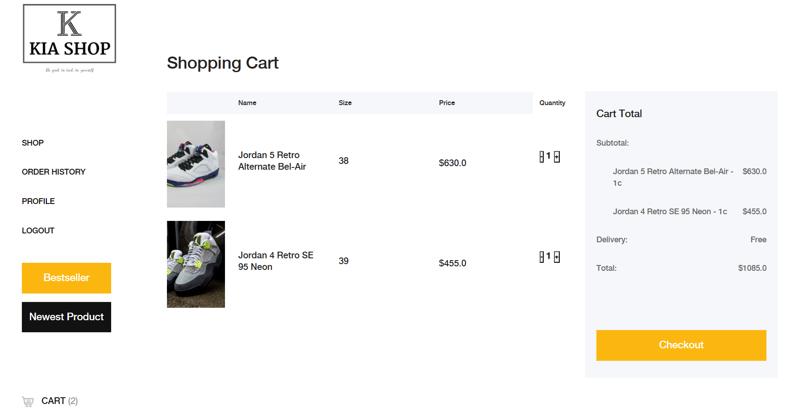

Step 6: click the CheckOut button

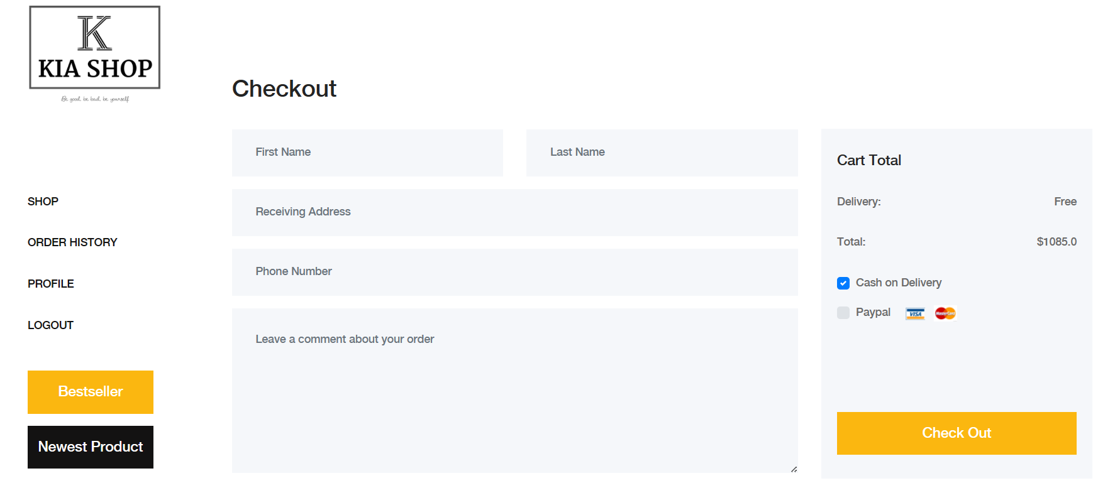

Step 7: Enter recipient information and click place CheckOut

## 12. Profile Management

Purpose: change information such as phone number, address, and fullname

Detail:

Step 1: Log in to the system with your registered email

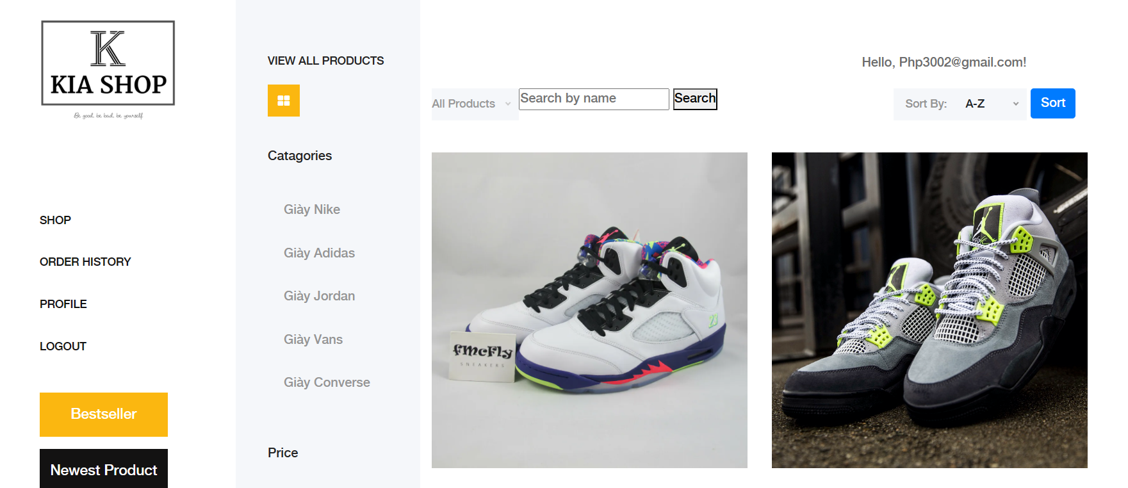Step 2:

- select the Profile button on the left of the screen

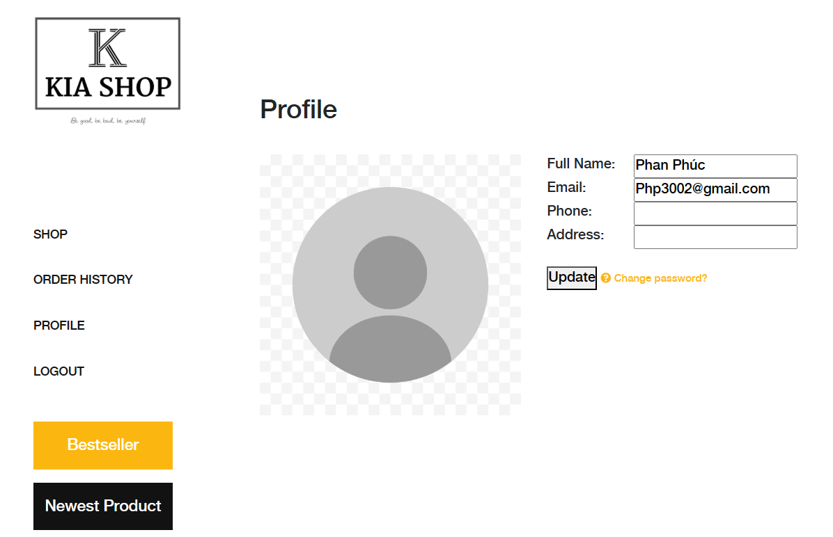Step 3: on the Profile page, change the information

- Enter the name you want to change

- enter address

- Enter your phone number

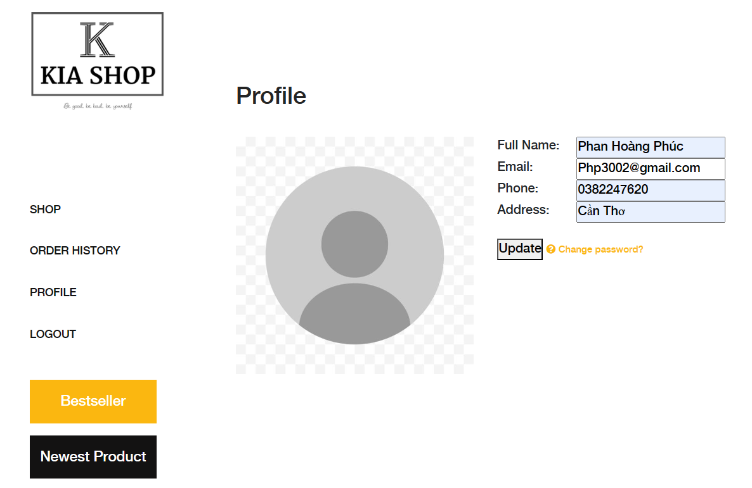

Step 4: select the update button to save changes

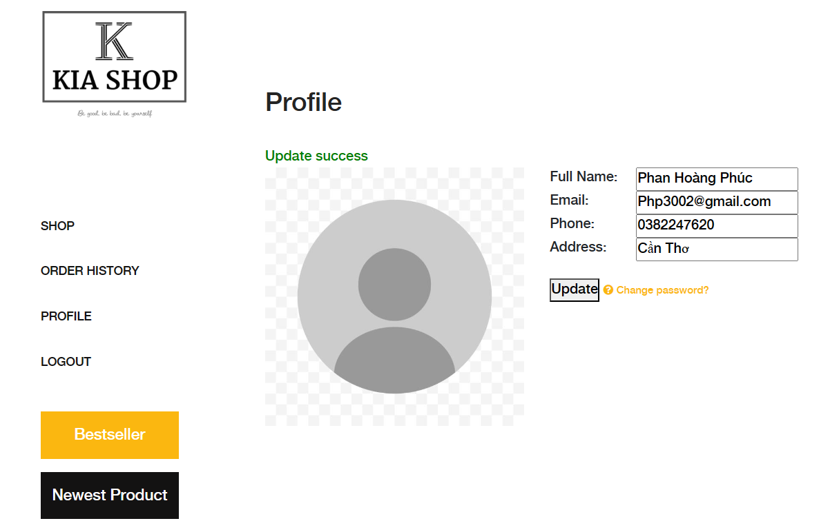

## 13. View Order history

Purpose: view history of purchased orders such as order date, orderer's name, phone number, order status

Detail:

Step 1: Log in to the system with your registered email

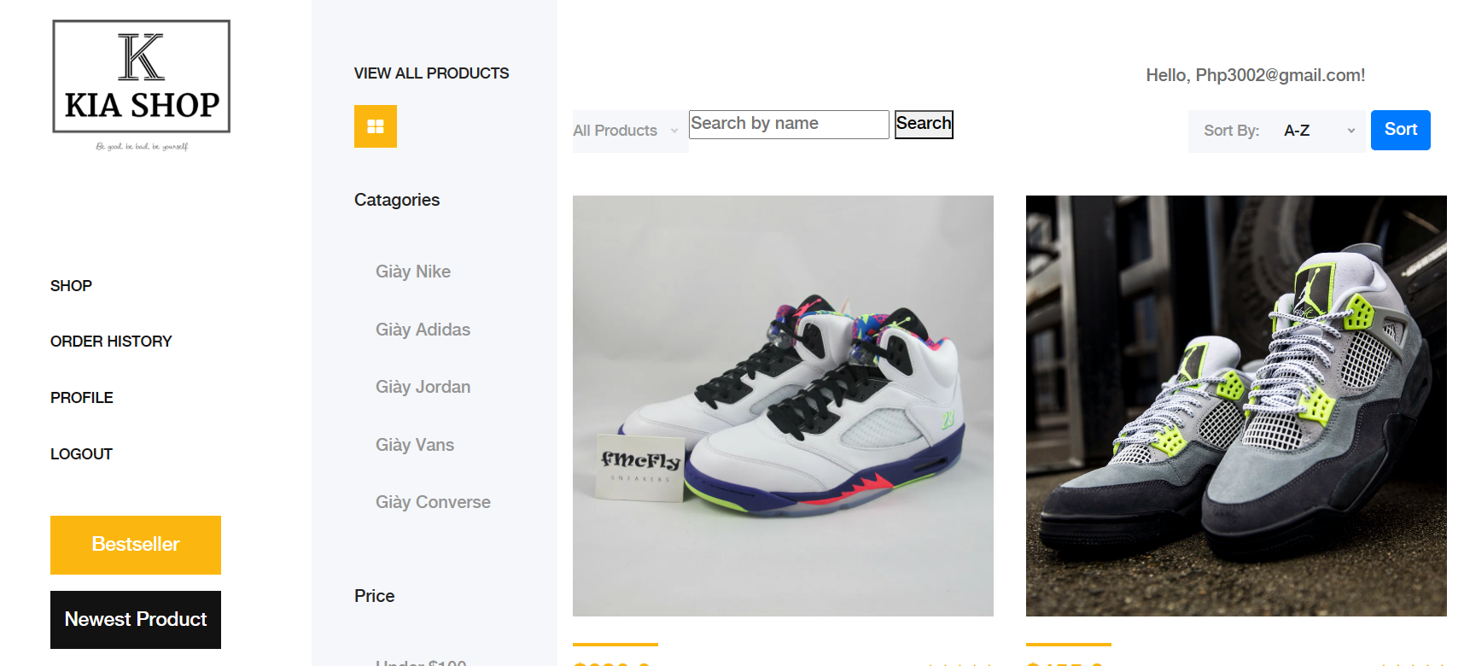Step 2:

- select the order history button 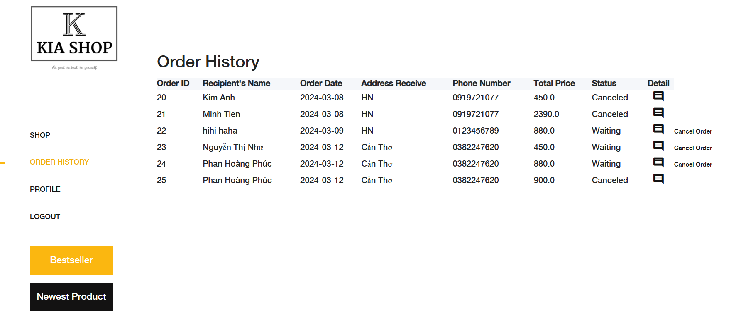

## 14. Cancel Order

Purpose: customers can cancel placed orders, clearly stating the reason for canceling the order to be able to cancel

Detail:

Step 1: Log in to the system with your registered email

Step 2: Select the order history button



Step 3: Select the cancel Order button

Step 4: The system checks again if you are sure you want to cancel

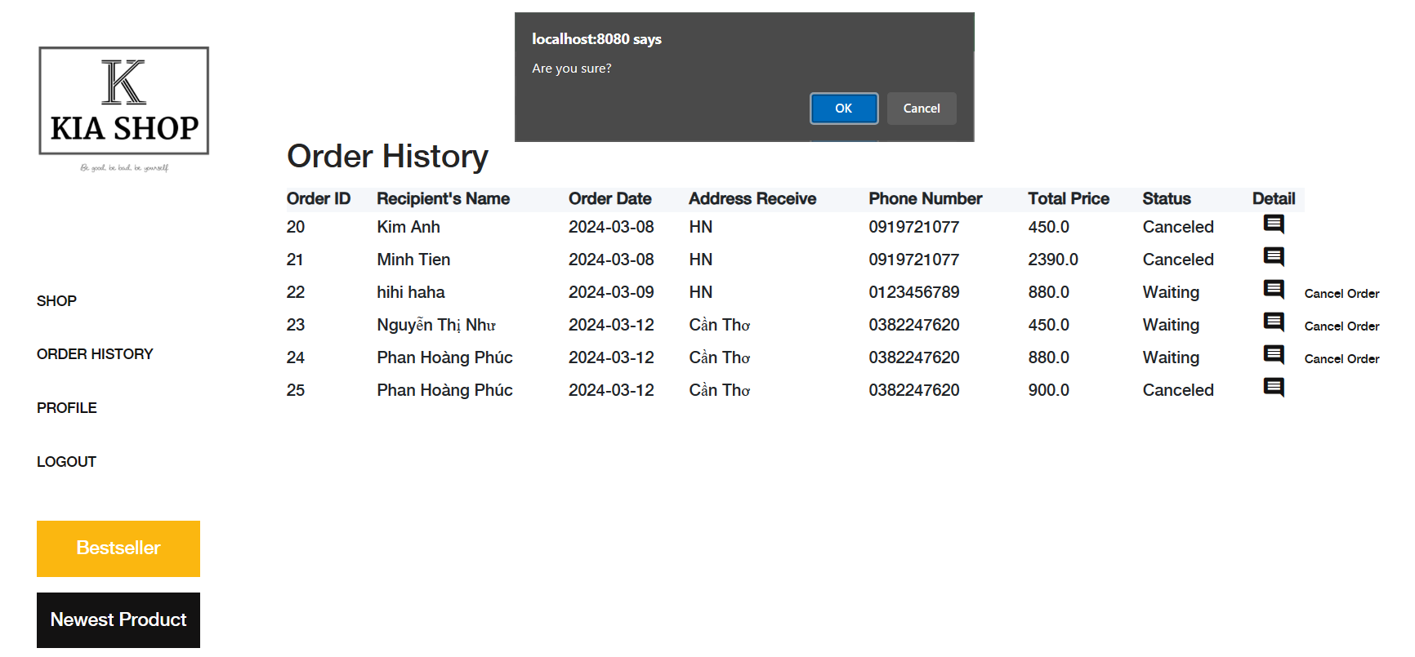

Step 5: Enter the reason for canceling the order and click "Ok"

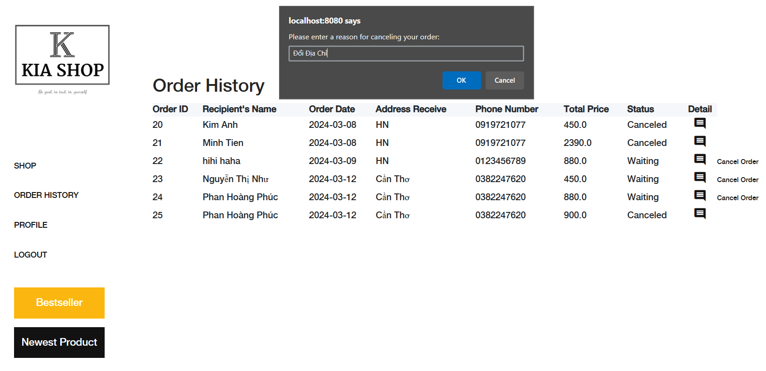

Step 6: The system updates the order status as "Cancel"

## 15. view order details

Purpose: customers can view details of the products placed in the order

Detail:

Step 1: Log in to the system with your registered email

Step 2:

- select the order history button



Step 3: select the Details button

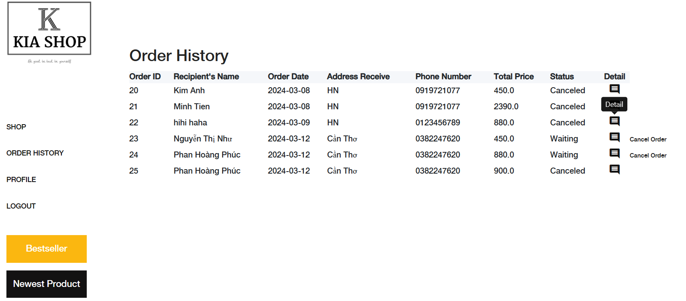Step 4: the system displays purchased product information

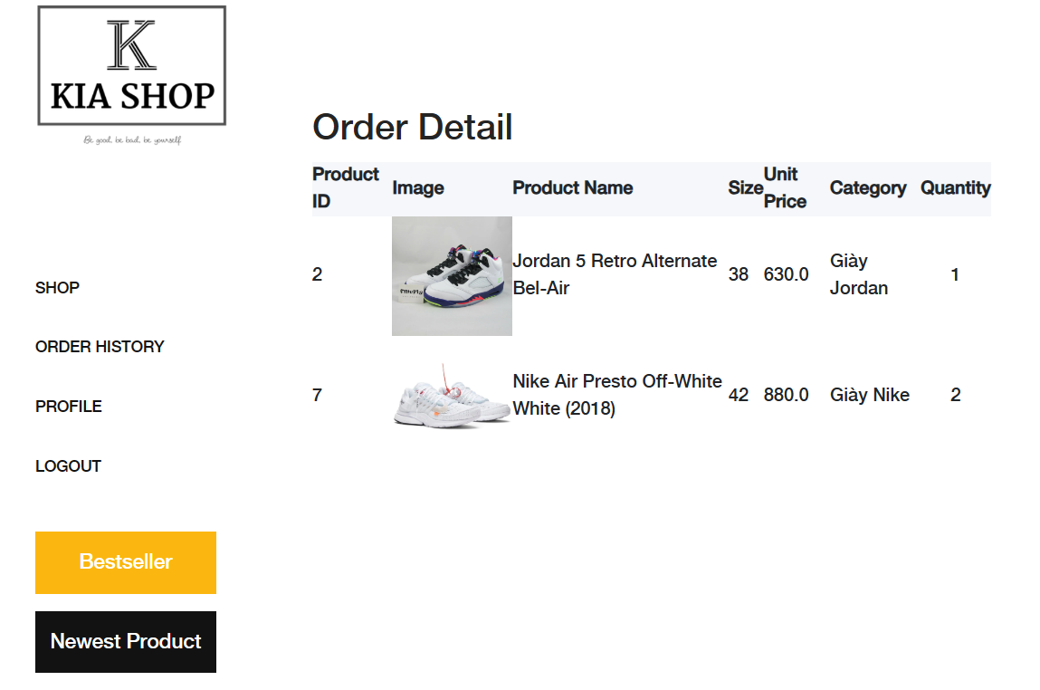

## 16. Add New Product Workflow

Purpose: The Add New Product workflow enables sellers or administrators to easily add new products to the KiaShop platform, expanding the product catalog and providing customers with more options for purchase.

Details:

Step 1: Accessing Product Management Interface

- Log in to the KiaShop platform with valid seller or administrator credentials.

- Navigate to the administrative dashboard or seller portal where product management tools are available.

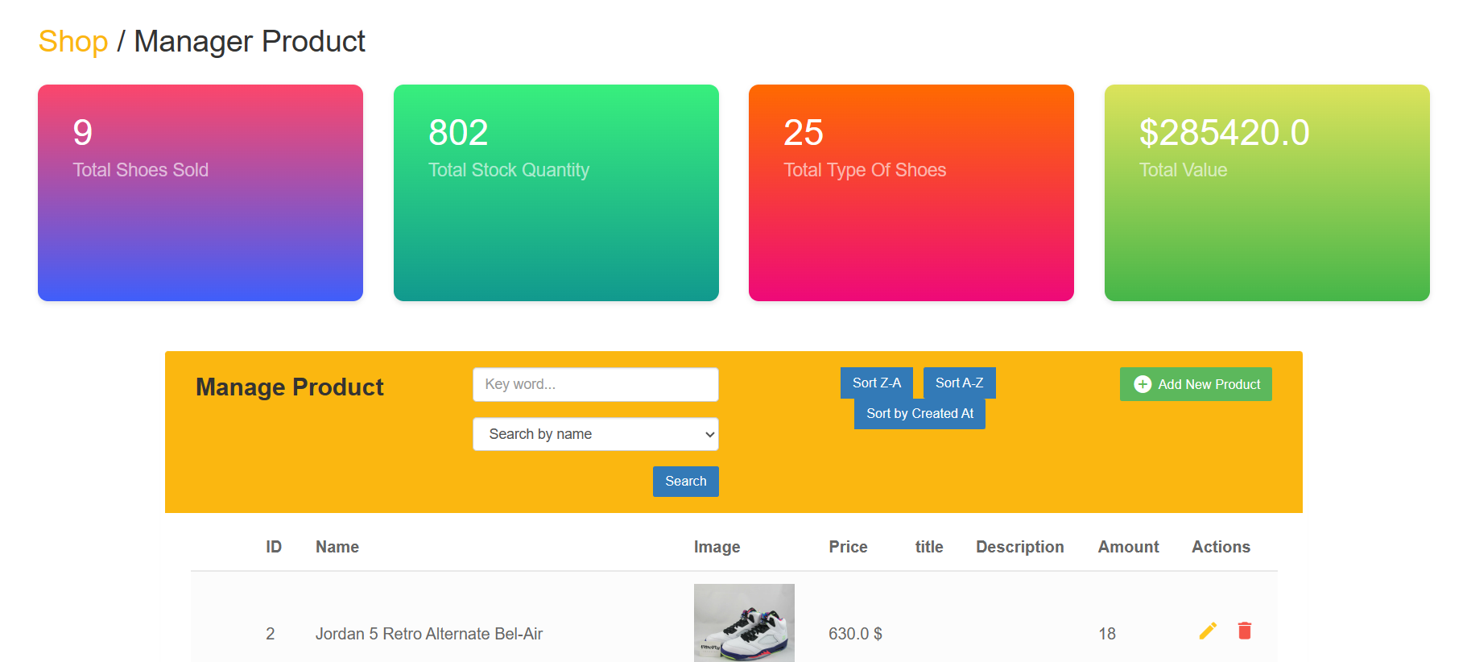Step 2: Initiating Product Addition

- Look for the option to add a new product. This may be represented by a button labeled "Add New Product" or a similar action prompt. - Click on the designated button to start the process of adding a new product.



Step 3: Entering Product Details

- Fill out the product information form with relevant details about the new product.

- Required information typically includes product name, description, category, price, availability, and product images.

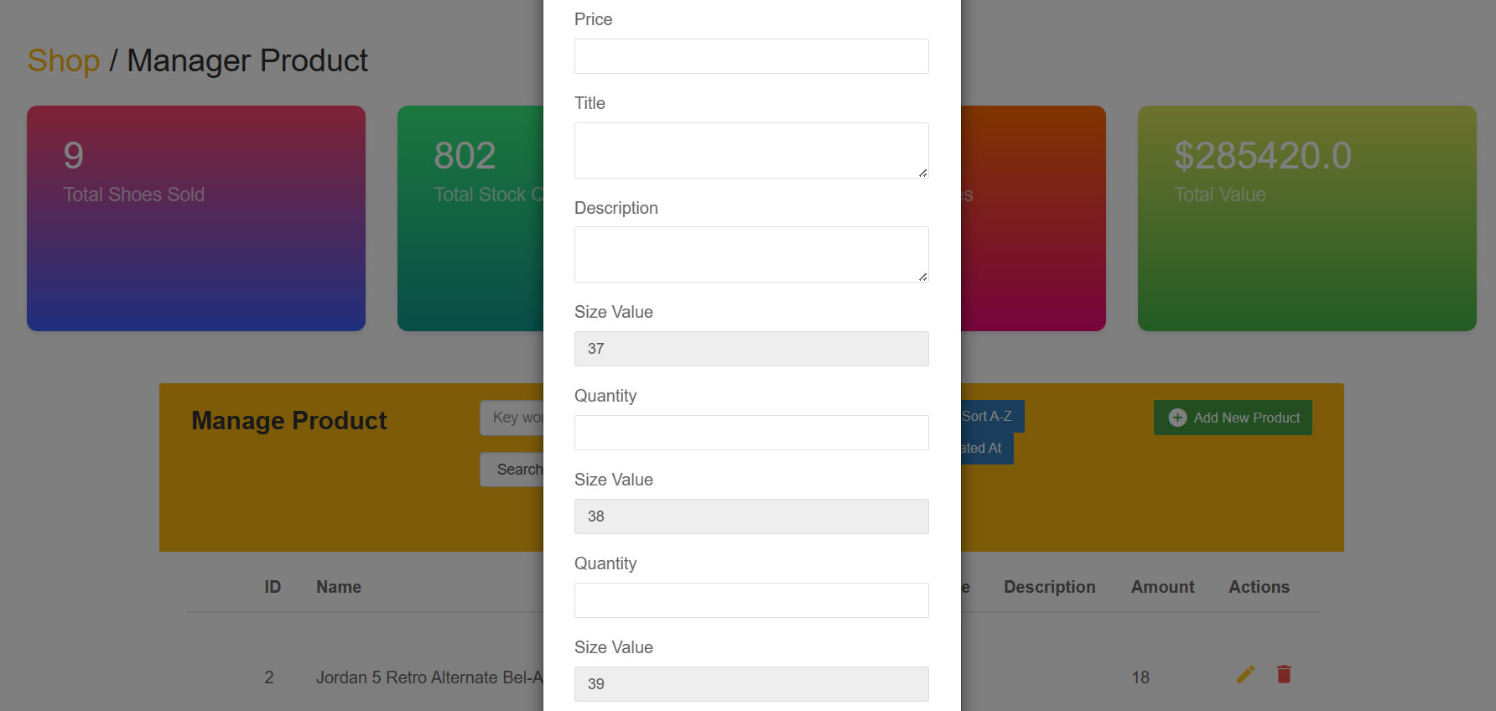

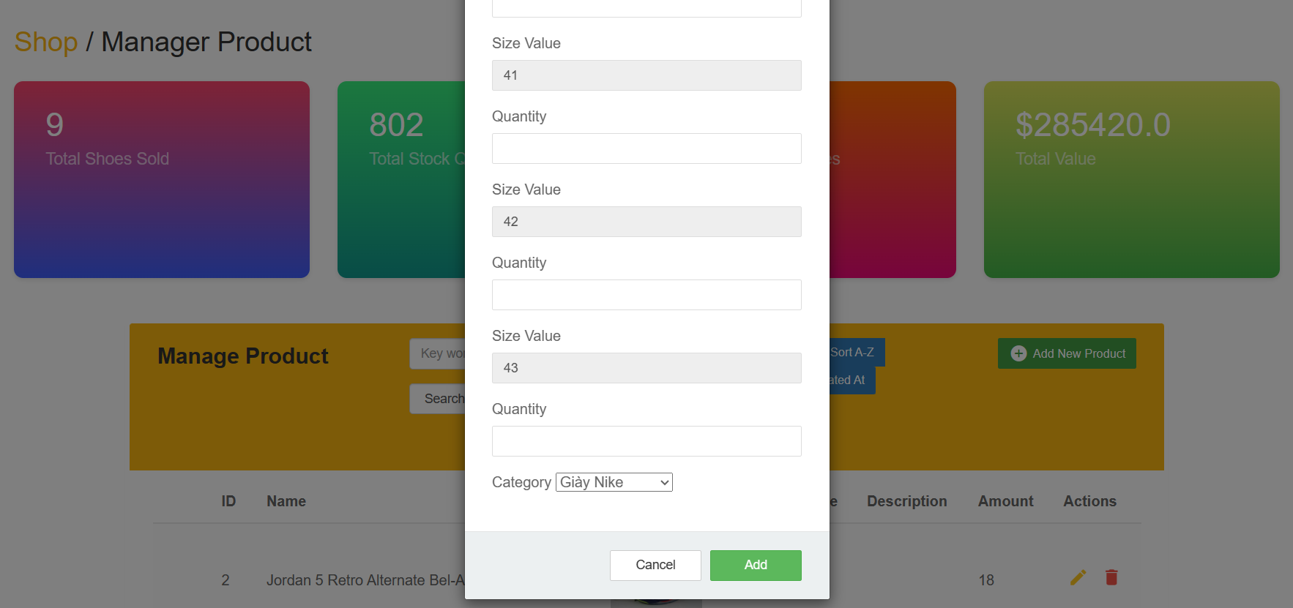Step 4: Uploading Product Images

- Upload high-quality images of the new product to showcase its appearance to potential buyers.

- Ensure that the images accurately represent the product and adhere to any platform-specific image guidelines.

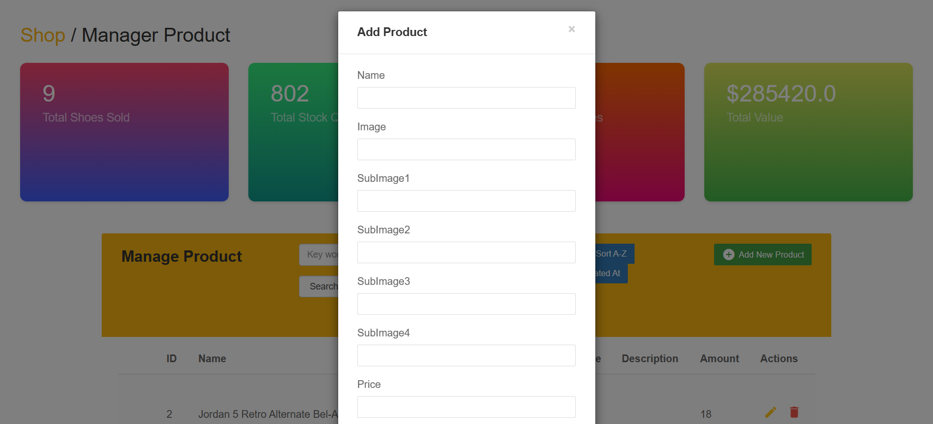

Step 6: Verifying Product Information

- Review the entered product information and double-check for accuracy and completeness.

- Make any necessary adjustments or corrections before proceeding to the next step.

Step 7: Saving the New Product

- Once all required information has been entered and verified, save the new product to add it to the KiaShop platform.

- Click "Add" to save or click "Cancel" to proceed with adding products.

Step 8: Confirmation and Visibility

- After saving the new product, confirm that it has been successfully added to the product catalog.

- Ensure that the product is visible to customers on the storefront and searchable within the platform.

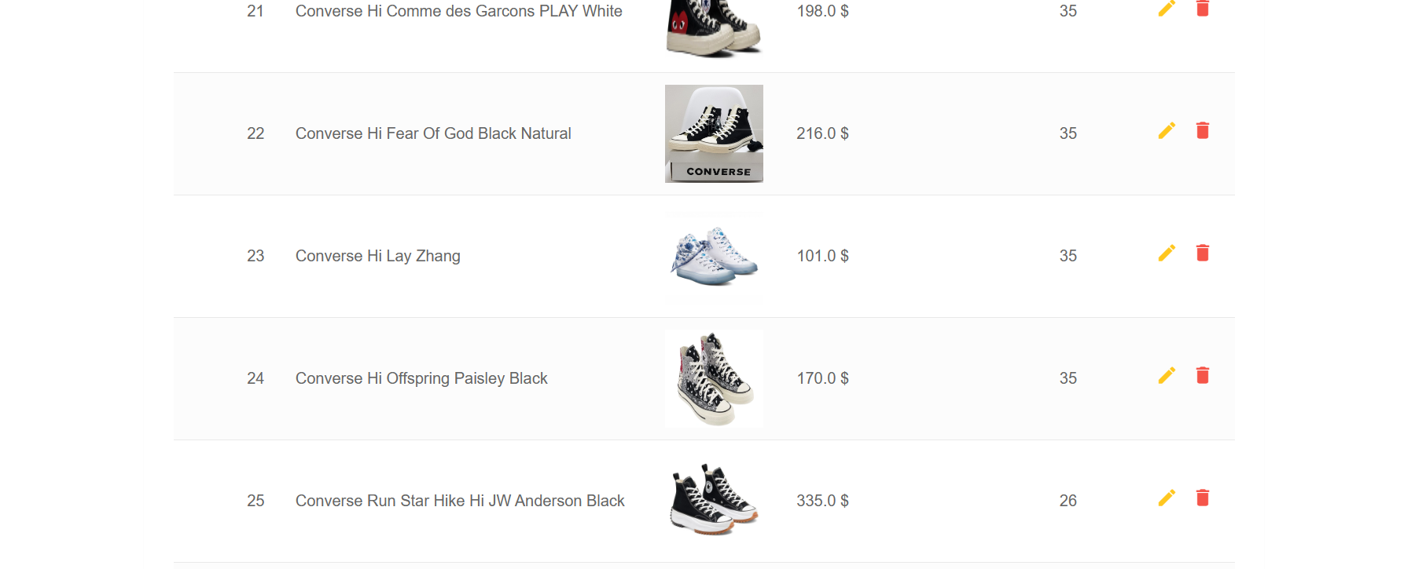By following these steps, sellers or administrators can efficiently add new products to the KiaShop platform, expanding the range of offerings available to customers and enhancing the overall shopping experience.

## Update Product

Purpose: product update process from the product information change management page

Detail:

Step 1: Log in to your account with the Admin account

- When launching the KiaShop application, Admin will be greeted with the home page.

- Admin logs into the system with the authorized email

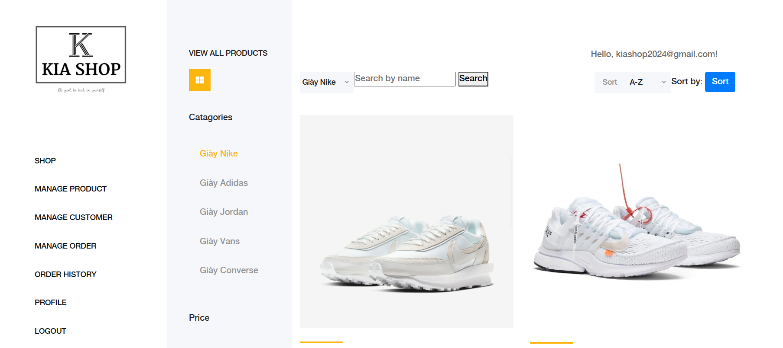

Step 2: go to product management

- go to product management and click on edit button

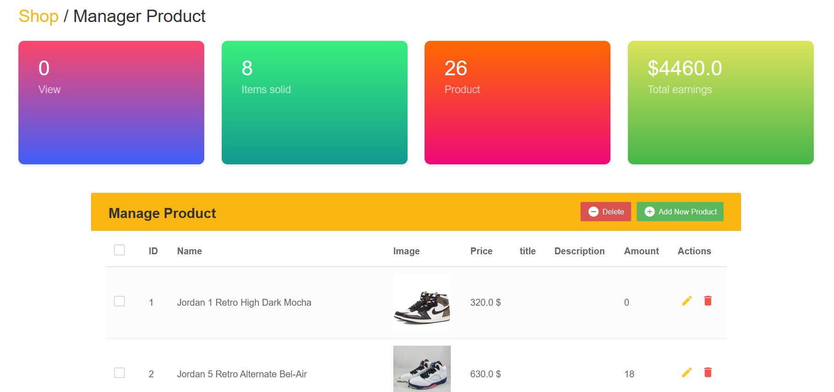

Step 3: enter the information you want to change

- After clicking the edit button, all product information will appear

- Re-enter the information you want to change and click submit

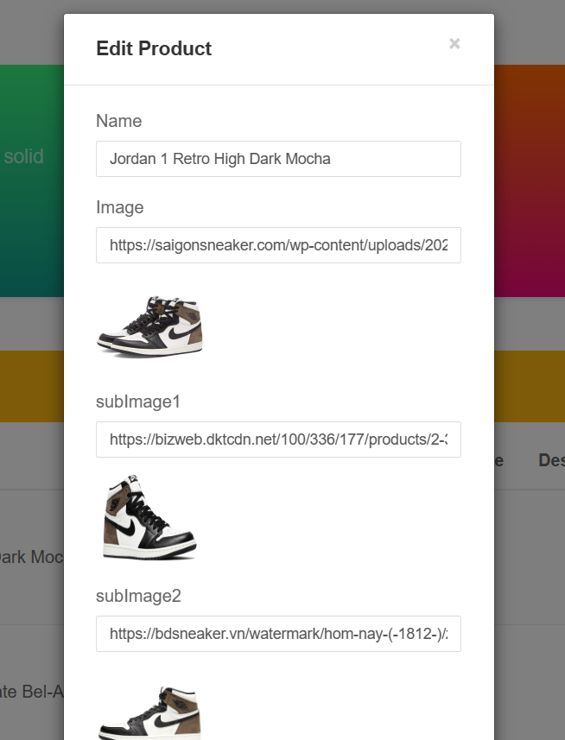

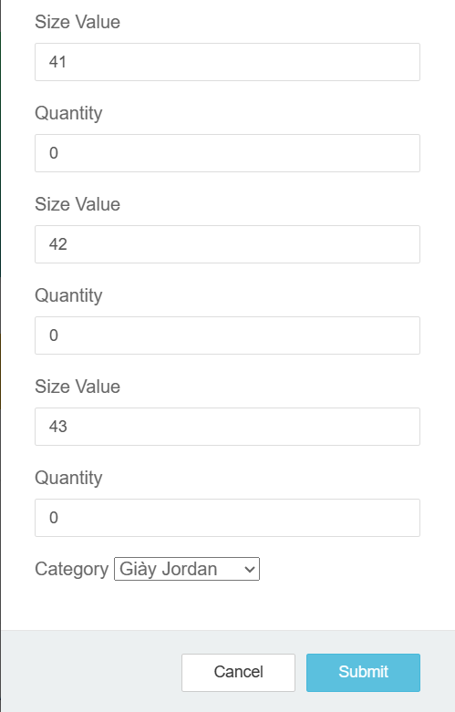

## Customer Management Workflow

Purpose: The Customer Management workflow allows administrators or customer service representatives to effectively manage customer accounts, interactions, and inquiries within the KiaShop platform, ensuring a seamless customer experience.

Details:

Step 1: Accessing Customer Management Interface

- Log in to the KiaShop administrative dashboard or customer management portal with valid credentials.

- Navigate to the section dedicated to customer management, which may be labeled as "Customers," "User Management," or similar.

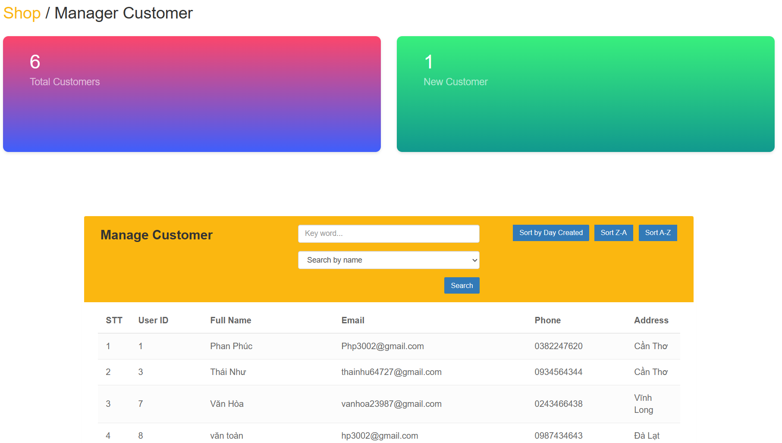Step 2: View customer list

- When accessing the customer management interface, a list of registered customers will be displayed.

- This interface will list the number of customers who have created accounts and the number of customers who have created new accounts

- This list usually includes necessary details such as customer name, email address, registration date and account status.

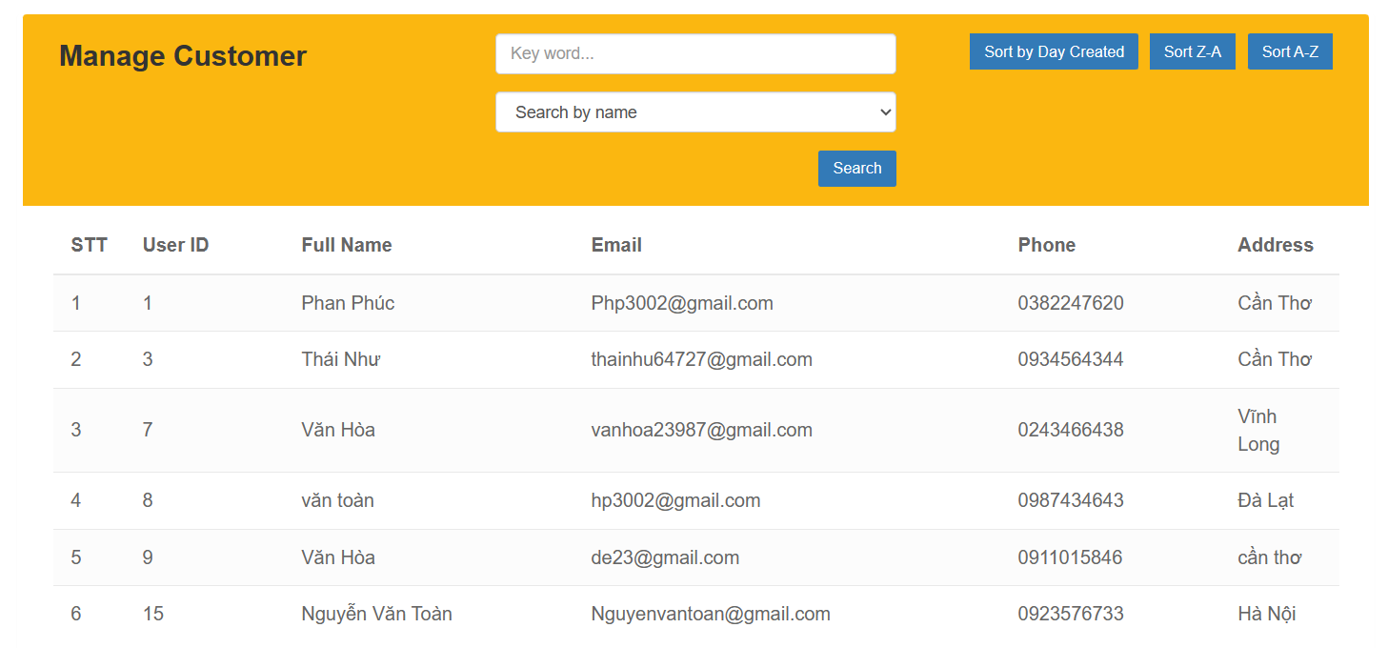3. Step 3: Filtering and Sorting Customers

- Utilize filtering and sorting options to narrow down the customer list based on specific criteria.

- Common filtering options may include sorting by registration date, account status, purchase history, or demographic information.

1. Sort Z-A

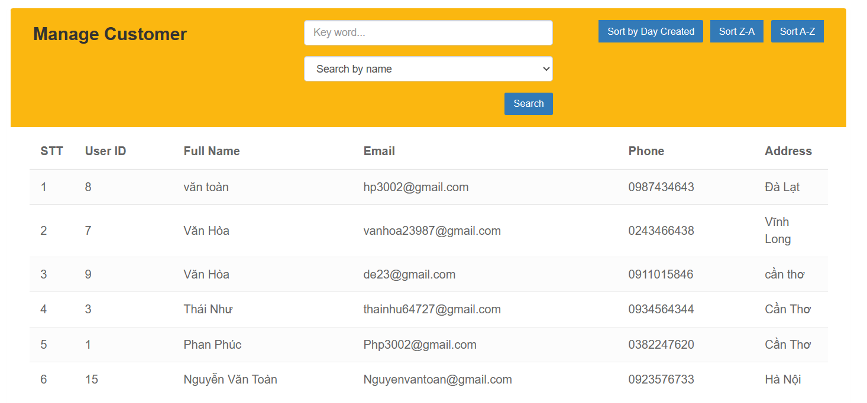

1. Sort By Day Created

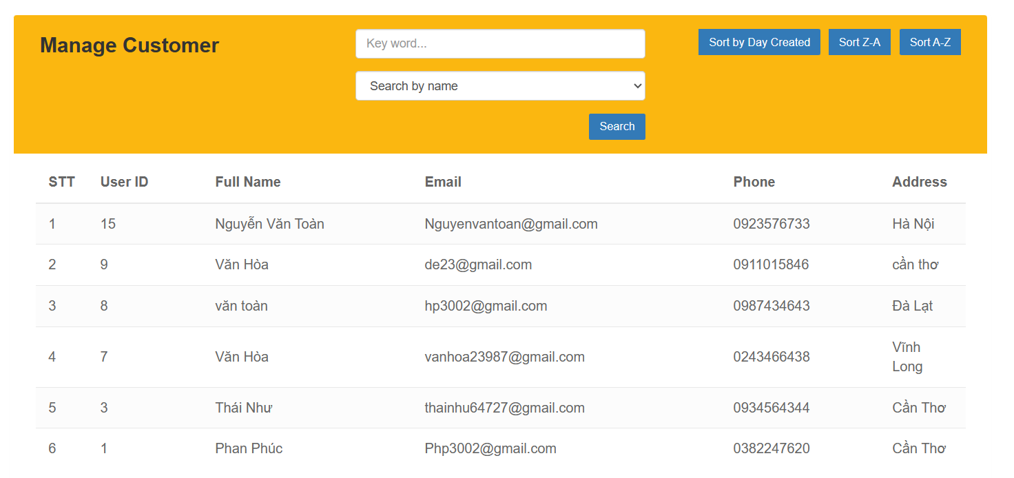

Step 4: search for customers by name and phone number

- Use search to find customers whose information the admin wants to see.

- common searches like names and phone numbers

1. Search By Name

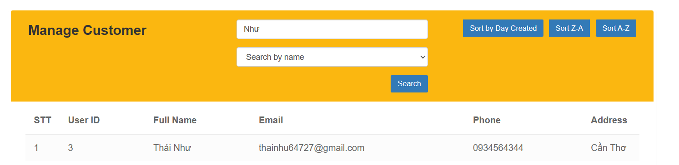

b.Search By Phone Munber

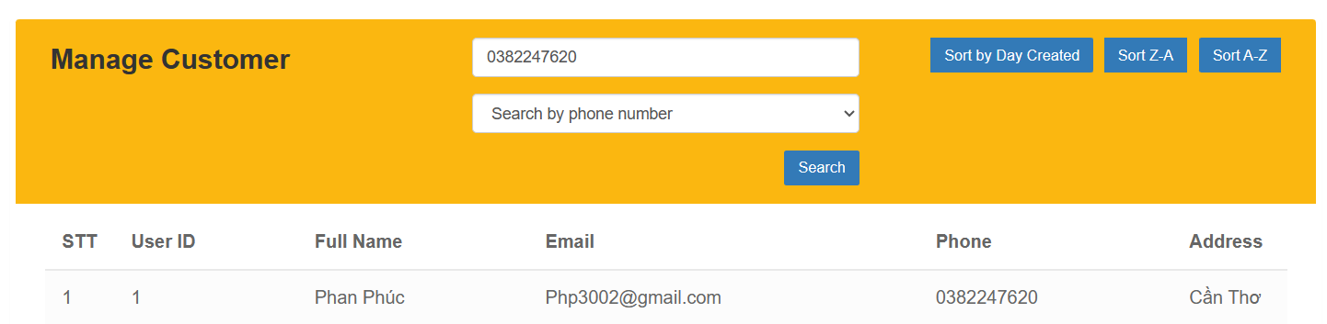

## 19. Order Management

Purpose: admin can view order details such as customer purchase date, admin can accept order or cancel order

Detail:

Step 1: log in to the system with authorized email

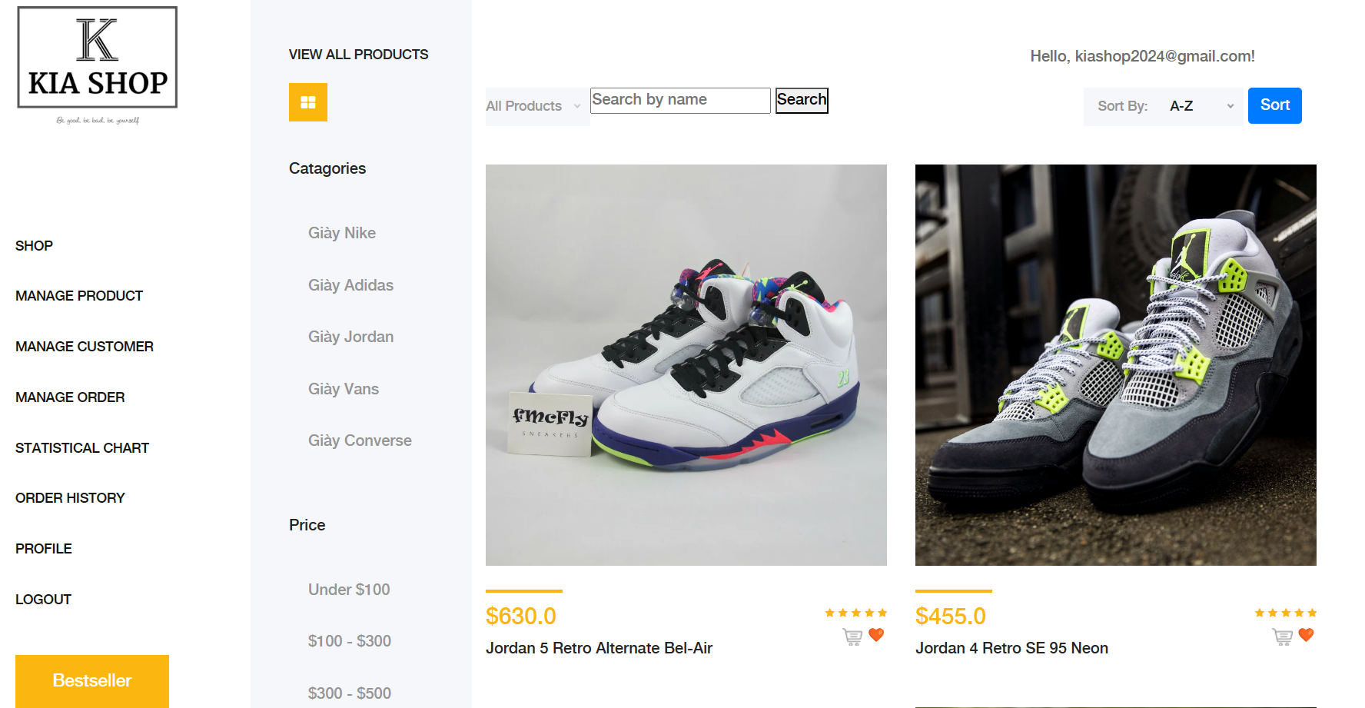Step 2:

- On the order management page there will be 2 options: accept and cancel

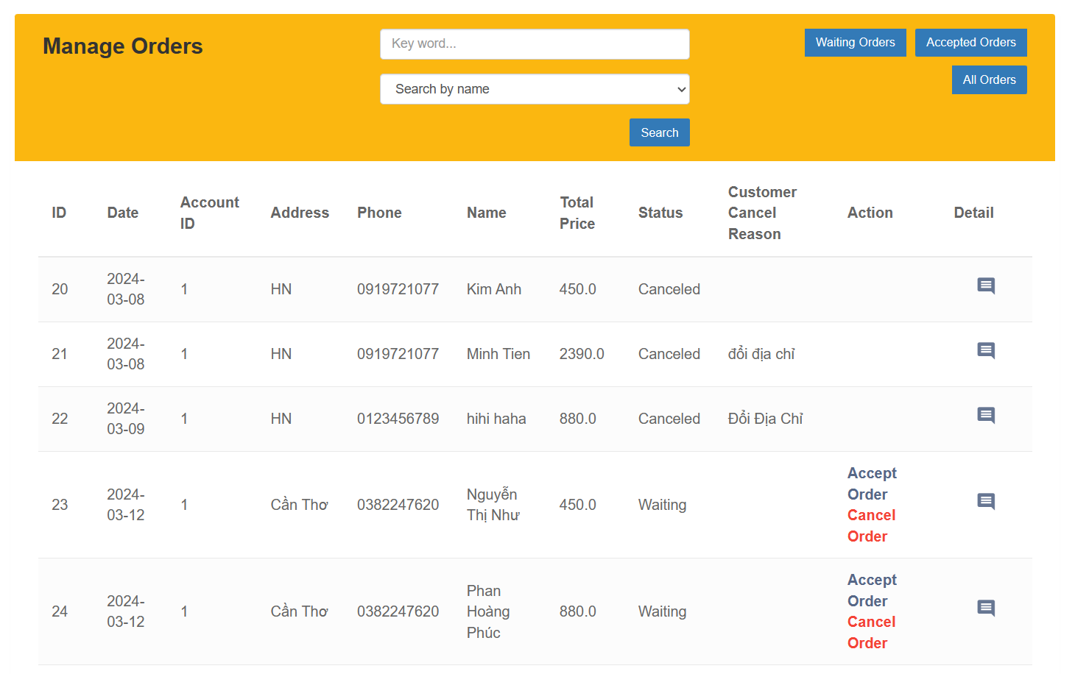

Step 3: Admin can view orders that have been accepted or orders that are waiting

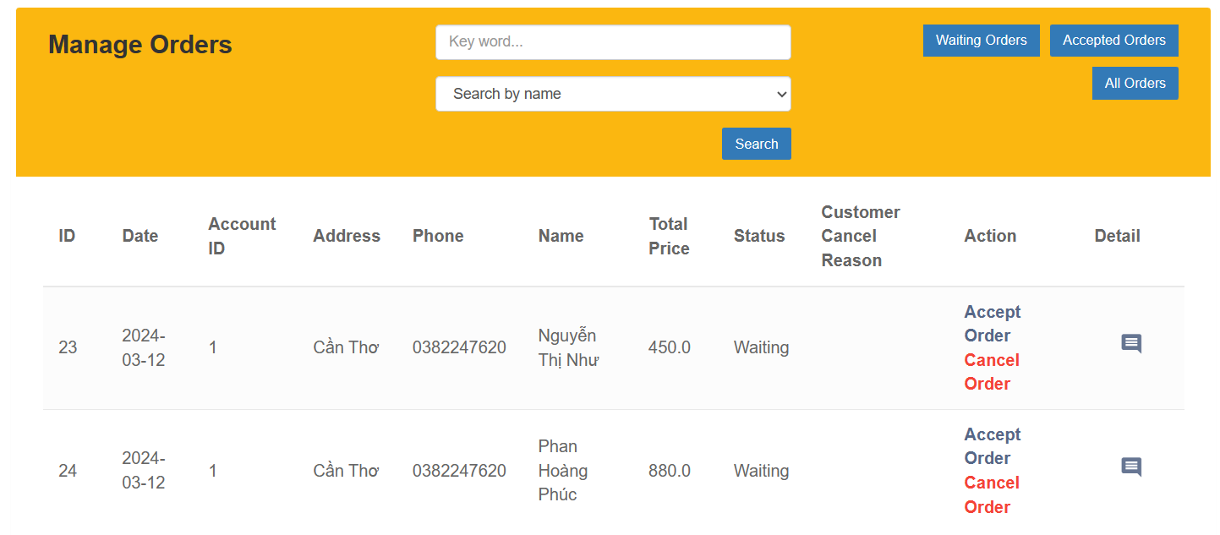

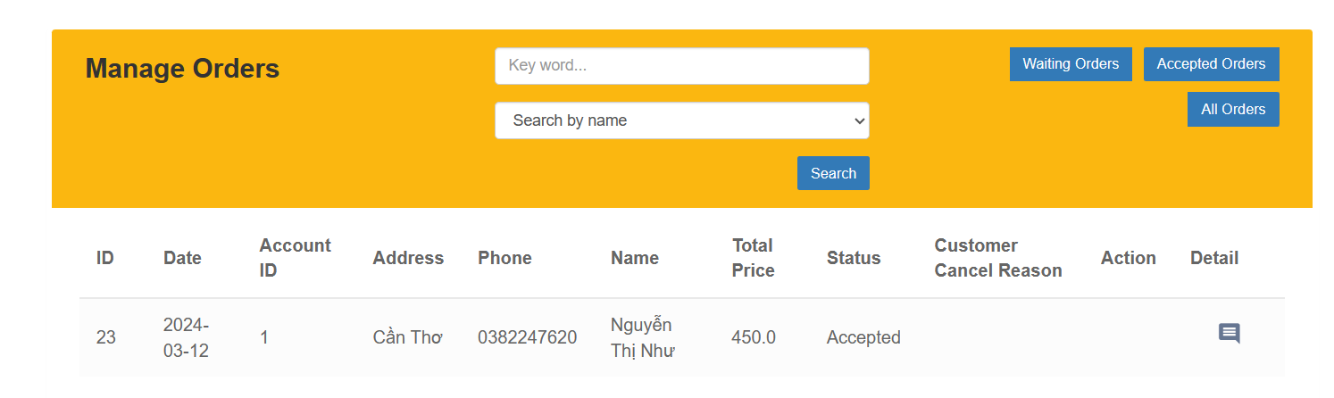

Step 4: Admin can search for orders based on customer name or customer phone number

